JAMSHED

JAMSHED.332821@2freemail.com

PERSONAL INFORMATION
h
DATE OF BIRTH:
13-September-1991
Marital Status:
SINGLE
RELIGION:
ISLAM
Visit Visa:
Entrance in UAE:
January 8, 20117
Expires:
March 29, 2017

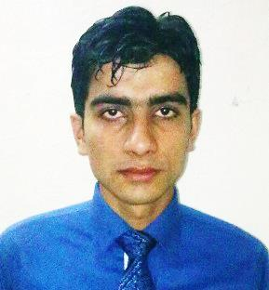

OBJECTIVE

Seeking to get a career oriented job in a professional environment that offers utilization of my skills and provide learning opportunities to keep pace with advanced ideas.

SCHOLASTIC CARRIER

YEARS OF COMPLETION/ TITLEOF DEGREE |  | DIVISION  CGPA | INSTITUTION
2016 | MBA  (Insurance& risk management) | 3.18 | UNIVERSTY OF PUNJAB
2012 | B.COM | 1st | UNIVERSTY OF PUNJAB
2010 | D.COM | 1st | PUNJAB BOARD OF TECHNICAL EDUCATION
2008 | MATRIC | 1st | MULTAN BOARD
2008 | COMPUTER SHORT COURSE |  | PUNJAB BOARD OF TECHNICAL EDUCATION

TECHNICAL SKILLS
- Familiar with Microsoft office (Word, Excel, Power Point)
- Familiar with adobe Photoshop
MANAGEMENT SKILLS

Customer Satisfaction, Effective communication skills, Team building, Time bound, Problem solving and decision making, Data verification.
EXPERIENCE
- 2 year in State Life Insurance as Sale Executive
- 1 year experience in Sawera departmental store as Sales man
- 1 year in Tagma Pharma Pvt (Ltd) as Account Officer
- 1 year in Al Rehman housing scheme as Accountant
- Successful execution of The Service Leadership Workshop of TCS Company Octara
EXTRA CURRICULAR ACTIVITIES

- Managed different events as an organizer successfully.
- Actively participated in all social activities during whole educational period.

COMMUNICATION SKILLS
- SPEAKING: Urdu, English, Punjabi
- WRITING: Urdu, English, Punjabi
- READING: Urdu, English, Punjabi

