CURRICULUM VITAES

SAMARTH SAMARTH.332823@2freemail.com
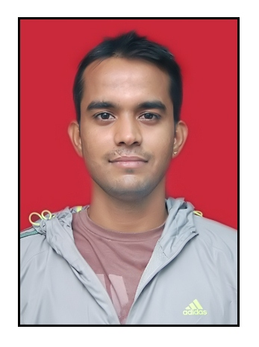

sssssss

CAREER OBJECTIVE

To work in a creative and challenging environment and effectively contribute toward the goal of organization.To serve the profession with outmost sincerity, dedication, devotion and intelligence.

PROFESSIONAL QUALIFICATION

Bachelor of Physical Education: Lakshmibai National University of Physical Education, Gwalior.
Masters of Physical Education: B.V.D.U College of Physical Education, Pune

TECHNICAL SKILLS

- Specialized in football.
- Proficient in Basketball, volleyball, Swimming, track & field, Badminton, fitness, yoga etc.
COMPUTER LITERACY

Fair Knowledge of “Computer Applications”

- MS-Office
- Power Point
- Knowledge of Internet

SPORTS PROFICIENCY

- Represented BVDU in All India Inter University in Baseball at Delhi (2013)

- Participated in west zoneInter University Football at Bhopal (2012)

- Participation in inter college competition (football, basketball, volley ball, cricket, badminton etc)

PROFESSIONAL EXPERIENCE

- 2 year Working experience in ACADEMIC HEIGHTS PUBLIC SCHOOL as PHYSICAL EDUCATION TEACHER.

- 1 year Working experience in LEAPSTART as PES

- 2months Internship at Sainik SchoolKarnal, Orgd. By(H.O.D) teacher education LNUPE, Gwalior in the year 2010- 2011.

- Summer coaching camp at LNUPE Gwalior.

- 2 Year Coaching experience of football at BharatiVidyapeeth Football club Pune.

- 1 Year Coaching experience of football at Bharati English Medium School, Pune.

- Presented paper in UGC sponsored National Seminar on women’s health through yoga, sports and physical education.

- Attended international conference at lonavla on yoga.

- Technical official in 1stPune Corporate Olympia.

- Technical official in Pune International Marathon .

RESEARCH EXPERIENCE
RESEARCH EXPERIENCE

- Working on the Thesis “Effect of sports drinks on cardiovascular endurance of a football player”.

CO-CURICULLAR ACTIVITIES

- Attended in the National Himalayan Tracking Expedition, Saurkundi Pass Orgd. By Youth Hostel Association of India (YHAI) in 2010.

- Attended in the Leadership Training Camp Pachmari (M.P) in the year 2009, Organized by LNIPE, Gwalior.

- Conducted an Off Campus Training Programmed on March Past and Mass Display at Green Field Hr. Sec. School,Gwalior for Inter-School Competition in the year 2006.

PERSONAL PROFILE

Date of Birth : 13th SEP 1987
Gender : Male
Marital Status : Single
Nationality : Indian
Languages : English& Hindi

DECLARATION

I hereby declare that all the information furnished above is true and correct to the best of my knowledge and belief. I hope you would give me a chance to interact with you.

