Cover Letter
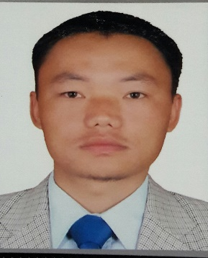
RABINDRA.332869@2freemail.com

To Kind Attention:
Human Resources Department,

Dear Sir/Madam,

It is with pleasure I take this opportunity to forward myself for your kind perusal. On the accompanying CV, I have set out those of my qualification and experiences, that I am sure will help you most in considering my application.

Should an interview be result of this application I will be prepared to elaborate further or forward my credentials, should the need arise. I appreciated your kind help.
I would like to thank you for your time and look forward for any reply.

Yours truly,

Rabindra

RABINDRA

POST APPLY FOR: Dental Hygienist/Dental Allied Healthcare (DHA)

PROFESSIONAL PROFILE:

Seeking a challenging position with a progressive organization that will effectively utilize my knowledge and expertise, where I can grow with the organization and prove to be an asset for its effective functioning, be a team player for the achievement of organizational goals and its success.
KEY SKILLS:

- Flexible and supportive team player with the ability to work to tight timescales
- Excellent verbal and written communications skills
- Capacity to work on own initiative as demonstrating a high level of team contribution
- Capable of managing stress as well as remaining calm under pressure
- Quick thinker and learner with the ability to multi-task.

EDUCATIONAL ATTAINMENT:
- Dental Hygienist Dental Allied Healthcare Approved from Dubai Health Authority(DHA)
- Dental Hygienist from Council for Technical Education and the Vocational Training (CTEVT) Kantipur School of Dentistry collage Kathmandu Nepal in 2003.
- Professional Certificate Level from National Institutes of open schooling New Delhi India.
COMPUTER KNOWLEDG:
- Basic computer knowledge such as MS word, MS excel email and internet.
WORKING EXPERIENCE

- Worked at Himal Dental Hospital& Institute of Dental Science Kathmandu Nepal from 1st May 2010 to 30th June 2016.
- Worked at Damak Hospital of Dental Department from 1st January 2008 to 21th April 2010.

DUTIES AND RESPONSIBILITIES

- providing dental health education about tooth care and diet
- removing plaque and calculus by scaling and polishing teeth
- taking impressions and/or dental radiographs of teeth
- applying prophylactic/antibacterial materials, fissure sealants and topical fluorides to help prevent tooth decay
- carrying out screening and monitoring procedures
- treating and helping to prevent gum disease
- ensuring that sterile conditions are maintained
- offering advice and encouragement to patients
- working closely with and under the instruction of dentists
- using a range of dental instruments
- keeping up to date with new developments within the profession and maintaining patient dental records

PERSONAL INFORMATION
  - Nationality : Nepalese
  - Date of Birth : 21 Sep 1980
  - Address : Dharan Sunsari, Nepal
  - Marital Status : Married
  - Sex : Male
  - Language : English, Nepali & Hindi

PASSPORT DETAILS
- Passport Issue : 30th Oct 2015
- Passport Expiry : 29th Oct 2025

I hereby certify that the above information mention is true and correct to the best of my knowledge and belief.

