Mennat
Mennat.332871@2freemail.com 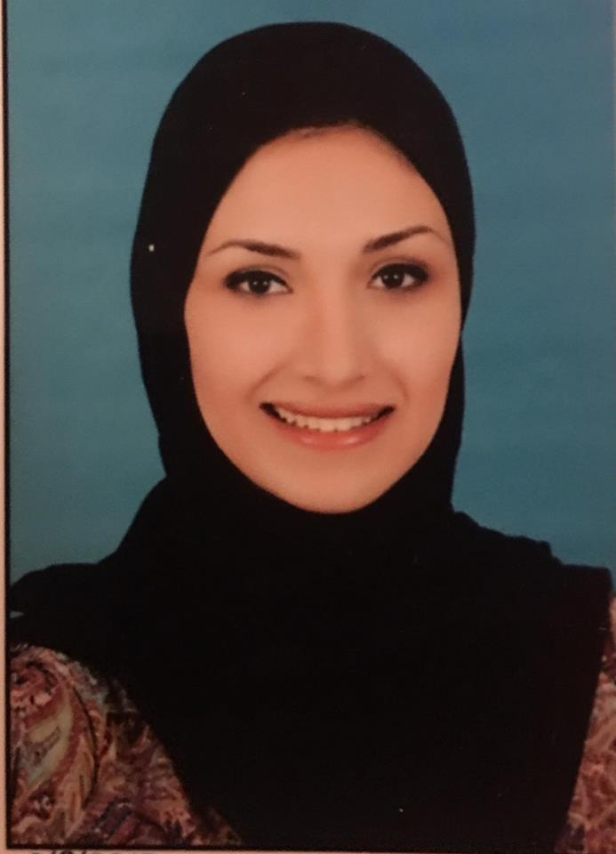
………………………………………………………………………………………

Career objective:
Seeking a challenging position in a dynamic environment with a desire to prove as an asset for the organization and be a team player for the achievement of organizational goals and its success.
Qualifications:

Degree: Bachelor Degree of Clinical Pharmacy
Year completed: 2014
Grade: Excellent (GPA 3.43)
University: Suez Canal University, Egypt

………………………………………………………………………………………………
Employment History:
*Current:-
Place: Pharma link Company
Location: Abu Dhabi, UAE.
Job title: medical representative.
Responsibilities:
- Organising appointments and meetings with community and hospital-based healthcare staff
- Identifying and establishing new business
- Negotiating contracts
- Demonstrating or presenting products to healthcare staff including doctors, nurses and pharmacists
- Undertaking relevant research
- Meeting both the business and scientific needs of healthcare professionals.
- Attending and organising trade exhibitions, conferences and meetings
- Managing budgets
- Reviewing sales performance
- Writing reports and other documents
*Previous:-
Place: Burjeel Hospital Pharmacy
Location: Abu Dhabi, UAE.
Duration: 2014 till 2016.
……………………………………………………………………………………………

Personal Details:
Marital status: single
Nationality: Egyptian
D.O.B: 7.8.1992
Languages: - Arabic (native)
- English (IELETS Overall score 6.5)
Computer skills: (word, Excel, PowerPoint)
Driving License: UAE valid license till 2025.
-Hard worker , responsible, creative, multi-task, flexible , have leadership & initiatives, easily trained, quickly integrated into work environment and teamwork willing to spend time and effort to reach the best level of knowledge.
-Ability to work under pressure and to meet deadlines.
-Controlling a team and assigning their tasks, ability to learn new tasks quickly.
-Ready to work in multinational companies.

