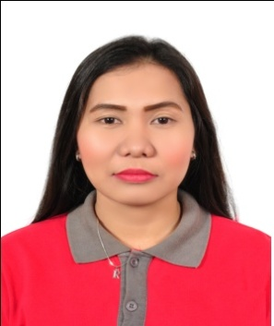
MERCY
MERCY.332873@2freemail.com

OBJECTIVES:
To be a part of your organization and be the asset of the company by sharing my knowledge and qualification. To used my skills in the best way for achieving the company goals and seeking for a responsible job with an opportunity for professional challenges.

EDUCATIONAL ATTAINMENT:

Tertiary level :
June 2009 – March 2013 BACHELOR OF SCIENCE IN COMPUTER SCIENCE (BSCS)
Erhard Systems Technological Institute
Poctoy, Odiongan Romblon
(Graduate)
Secondary Level :
June 2005 – March 2009 Romblon National High School
Dapawan, Odiongan Romblon
Elementary:
June 2000 – March 2005 Anahao, Elementary School
Anahao, Odiongan Romblon

WORKING EXPERIENCE:

Jan. 01, 2015 – Jan.07, 2017 SALES CREW

Shoes Palace Trading L.L.C (SHOBRA)

Main Street Al Ain

Jan. 06, 2013 – Jul.20, 2013 MINIS TOP STORE Crew

Makati Philippines

Dec. 01, 2012– Apr.17, 2012 LAND BANK OF THE PHILLIPINES

Odiongan, Romblon, Philippines

QUALIFICATION:
- Excellent in Costumer Service
- Self motivated individual who welcome challenges.
- Proven ability to work with minimum supervision.
- Honest, hardworking and fast learner.
- Multitasking personalities.
- Excellent in Costumer Service
- Can speak little in Arabic

PERSONAL PROFILE:

DATE OF BIRTH: December 11, 1992
PLACE OF BIRTH: Romblon Philippines
NATIONALITY: Filipino
AGE: 24
CIVIL STATUS: Single
HEIGHT: 5’3”
WEIGHT 55 KG
RELIGION: Roman Catholic
LANGUAGE: Tagalog, English, Arabic (Basic)

I hereby certify that the above information is true and correct to the best of my knowledge and brief.

