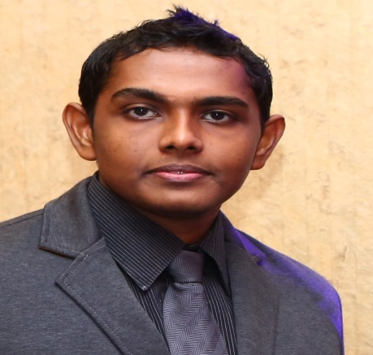
INDULAL.332901@2freemail.com
Industrious performance driven leader with 9+ years’ experience in the Administration. Deliver success through building, leading & inspiring teams to realize performance. Dedicated to providing comprehensive solutions that satisfy organisation’s goals. Proven track record of excellent interpersonal abilities fostering and maintaining positive professional relationships. Effective communicator with executive functional and technical associates across various levels of an organisation. Top-flight qualifications include

WORK EXPERIENCE

ADMIN Executive JULY 2014-JULY 2016
Zabeel International Institute Of Management & Technology Dubai, United Arab Emirates
Zabeel International Institute of Management & Technology was established in 1988 is a leading Executive Educational and Professional Training Centre in UAE with ten branches across the country. It is accredited by the KHDA (Knowledge & Human Development Authority) & Ministry of Education in Dubai as well as by the University of Cambridge International Examination Board, UK.

- Customize the course as per the client requirement, in liaison with academic director.
- Directs all aspects of Branch Management includes generating revenue for the branch while controlling expenses.
- Accomplishes staff results by communicating job expectations; planning, monitoring, and appraising job results; coaching, counseling, and disciplining employees; initiating, coordinating, and enforcing systems, policies, and procedures
- Suggesting the Appropriate course to the client after detailed Consultation.
- Organizing promotional seminars for promoting the Institute.
- Complaint handling and redressal.
- Liaison with Corporate clients for Corporate Trainings as well as Student Placements.
- Maintaining and monitoring of internal / external exam structures.
- Regular monitoring and analysis of front office activities.
- Present new products and services and enhance existing relationships.
- Work with technical staff and other internal colleagues to meet customer needs.
- Arrange and participate in internal and external client debriefs.

admin officer feb 2013 to feb 2014
Aakash Educational Services Pvt Ltd Kochi ,India
Aakash Educational Services Ltd. has emerged a benchmark in the arena of ‘Coaching & Guidance’ with its excellent performances in various Medical and Engineering Entrance Exams across India ever since its inception in 1988. Taking the legacy of excellence forward, today, Aakash has become synonymous with quality coaching for ‘Medical & Engineering’ Entrance Exams with 100 branches across the country.
- Directs all aspects of Branch Management includes generating revenue for the branch while controlling expenses.
- Mentoring and guiding the team of counselor’s and marketing staff for extracting their maximum efficiency.
- Continuous monitoring and discussions with Academic head’s to follow up through the syllabus completion of the courses and quality of teaching.
- Responsible for complete Admin, HR and Accounting functions of the Branch.
- Ensuring financial targets are met in time
- Organizing promotional seminars for promoting the Institute.

ADMISSIONS OFFICER JANUARY 2006 to JANUARY 2013
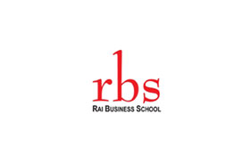
RAI BUSINESS SCHOOL Kochi ,India
RBS headquartered in New Delhi, India is one of India’s foremost B-Schools which are ranked amongst Top 20 B-schools with A+++ category The Rai Business School Offers a wide range of management programs through its various campuses across India to suit the diverse needs of aspirants.. At present RBS is having 9 campuses in India ie: Bangalore, Bhopal, Chennai, Faridabad, Hyderabad, Jaipur, Kochi, New Delhi & Raipur.
- Responsible for complete Marketing and Business development activities for Kerala and Tamil Nadu(India)
- Generating and Managing education agency channels throughout Kerala state.
- Implement Marketing strategies as outlined in the admissions plan in the target territories, attends educational and college fairs, meetings, and events.
- Identifying target audiences, planning marketing activities to achieve volume estimations & Converting potential candidates into clients.
- Ensuring financial targets are met in time
- Organizing promotional seminars for promoting the Business School.

EDUCATION AND TRAINING.

- Post-Graduation – MBA Marketing and HR –Anna University Chennai, India 70% (2004-2006)
- Graduation – B.A.Economics- Mahatma Gandhi University, India - 61%(2000-2003)
- Plus-Two- Higher secondary Education(India)-70 %(1998-2000)
- Matriculation Central. Board Of .Secondary.Education (India) -61 %(1986-1998)
- PMP-Project Management Professional Training from Zabeel International Institute Of Management and Technology(2016)

highlights and achievements
- Represented Uniglobe Resettlement solutions in an International conference conducted by WISE Program for Education Leadership in Kingdom Of Qatar.
- Awarded Best Manager Award in the Year 2007 for generating Maximum number of Educational agents in Kerala Circle
- Educational Credentials attested by the Embassy of U.A.E and the Ministry of External affairs, India.
- Valid U.A.E Driving License

declaration
I hereby declare that the information furnished above is true to the best of my knowledge. I am also Confident of my ability to work in a team.

Place: Dubai
Date: 9/1/2017

