**BINCY**

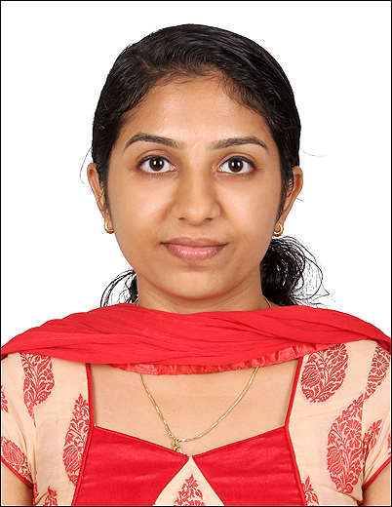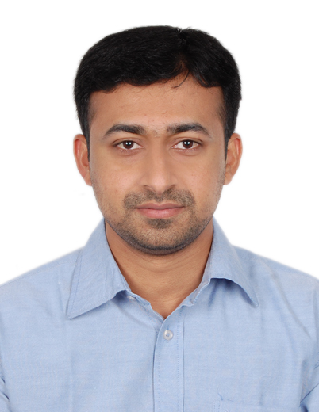

[**BINCY.332928@2freemail.com**](mailto:BINCY.332928@2freemail.com)

# **CURRICULUM VITAE**

# **Medical Coder**

**Professional Objective**

“To secure a challenging position as Medical Coder with a dynamic organization that offer career growth and where my experience and sound knowledge of **Professional coding** can be utilized best to the benefit of the organization. “

### Personal attributes:

* Extensive knowledge of ICD-10 and CPT-4 codes.
* Excellent knowledge of legality and ethics of the medical field.
* Knowledgeable in medical terminology and hospital, clinic & laboratory procedures.
* Proficient in assigning appropriate medical codes to diagnosis and services.
* Ability to manage time effectively.
* An understanding of Human Anatomy and Physiology.
* Ability to speak in a confident and assertive manner.
* To work effectively under pressure.

**Education & Qualifications:**

* Completed ICD-10, CPT, HCPCS LEVEL II & Medical Billing (Aldos Medical Services Pvt. Ltd, Kerala-India)
* Bachelor Degree in BSC Nursing. (M.G. University, Kerala-India)

**Technical Knowledge & Skills:**

* MS Office
* EXCEL
* Power point

**Professional Experience**

More than 2 years of experience as a Staff Nurse in the Reputed Hospitals in Kerala -India.

**Professional History**

*September 2016 to November 2016*

Training **Medical Coding & Billing**

Institution **ALDOS MEDICAL SERVICES PVT. LTD.**

*April 2014 to October 2015*

Position **Staff Nurse** (Gynecology & Obstetrics Department)

Hospital **Ernakulam Medical Centre** **(EMC)** -Kerala -India.

Duties & Responsibilities:-

* Transporting the Gravid Patients to Labour room.
* FHS Monitoring, Vaginal Examination, Cannulation & Catheterization.
* Preparation of LSCS like Abruption Placenta, Previous caesarian Patient & New Born Care.
* Antepartum, Intrapartum and Postpartum Care.

*October 2013 to May 2014*

Position **Trainee Nurse** (Medical and Surgical Department)

Hospital **Ernakulam Medical Trust** -Kerala -India.

Duties & Responsibilities: -

* Admission and discharge procedures.
* Preoperative and postoperative care
* Administration of whole blood, blood plasma & platelets.
* Surgical wound dressing.

### Personal Details

Nationality Indian

Date of Birth 19/04/1989

Marital Status Married

Languages known English & Malayalam

**Declaration**

I hereby declare that the above information is true to the best of my knowledge and belief.

With regards,