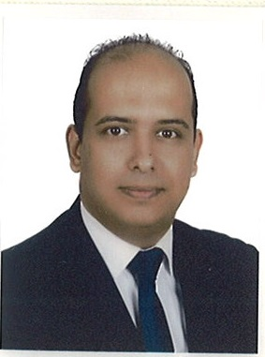
Tamer
Tamer.332931@2freemail.com

Objectives:

Seeking for a challenging opportunity, acquiring experience by which my skills and knowledge be effectively utilized and enchaced

Working Experiences

COMPANY: ABU DHABI COMMERCIAL BANK

FROM MAY 2015 TILL PRESENT

Job title: senior relationship officer
- Consumer banking
- Islamic banking
- Multi products

Company: AL HILAL BANK

From April 2013 till MARCH 2015

Job Title: Sales & Service Officer
(All Retail Products)
- Personal Finance
- Home Finance
- Auto Finance
- Credit Cards

Company: ABU DHABI ISLAMIC BANK

From June 2012 till March 2013

Job Title: Sales & Service Officer
(All Retail Products)
- Personal Finance
- Home Finance
- Auto Finance
- Credit Cards

Company: ACE LIFE INSURANCE COMPANY – EGYPT

From Feb 2011 till May 2012

Job Title: Financial Advisor
- Educate customers on the type of insurance the company is providing.
- Keeping a market comparison on different competitors.
- Analyzing the best possible Insurance to meet the customer needs.
- Providing after service sales call.

Company: RAK BANK

From Sept 2009 till Sept 2010

Job Title: Relationship Officer
- Ensure excellent customer service.
- Responds to customer inquiries.
- Promote & cross sell all retail products

Company: BARCLAYS BANK

From May 2008 till June 2009

Job Title: Auto Finance Representative
- Selling auto products to the retail customer
- Ensuring Targets are met every month

Training:

(RAKACADEMY)

- Customer service skills
- Communications skills
- Sales skills
- Presentation skills
- Writing email skills

Personal Qualifications:

- Marketing &Selling skills.
- Time management &organizational skills, ability to work under pressures.
- Communication & Interpersonal skills.
- Focusing on results& assuring that targets are always met.
- Accurate & Alert.
- Customer Centric.

Personal Details:

Date of Birth: 20 may 1984
Driving License: Dubai – UAE
Type of Visa: UAE Residence

Education:

Kafrelshekh University - Egypt
Graduated 2007

Bachelors in Faculty OfSocial Service

Language Known:

Arabic: Excellent
English: Excellent

