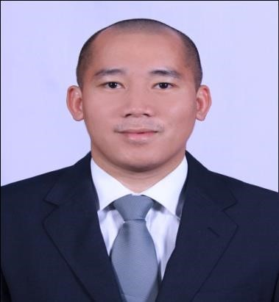

PERSONAL SUMMARY

MOHAMAD mohamad.332932@2freemail.com

-


An ambitious, highly motivated and energetic sales executive with excellent marketing and business development skills. Experience of managing sales and merchandising for established retails outlet. Over 6 years of marketing experience, working in competitive industries and successfully identifying, developing and managing new business opportunities within these markets.

PROFESSION: Merchandiser, Sales Executive

CAREER HISTORY

SALES EXECUTIVE- AL-SHAHEEN ESTABLESHMENT

MAY 2011-Present

Doha, Qatar

Involved in the strategic market planning for the company’s services. Organized merchandising operation and major events like promotions or product launches.

- Supervise the daily sales activities.
- Review and process purchase orders.
- Conduct market reaserch and product evaluation.
- Participate and attend various sales meeting.
- Prepare documents and minutes of the sales meeting.
- Involved in the traning of new staff merchandiser.
- Increase average monthly direct sales.
- Making sure products and services are supplied to the customers on time.
- Involved in forecasting market trends.
- Reporting to the General Maneger.
- Launched and distributed company product over 8 major accounts.
- Regularly liased with our suppliers to ensure the progress of existing orders. ➢ Provide customer with competitive quotation.

SHOWROOM SUPERVISOR- AL-SHAHEEN ESTABLESHMENT

MAY 2009-MAY 2011

Doha, Qatar

- Greeting customers upon arriving in our retail showroom and learning their motivation for their visit; and developing long-term relationships.
- Maintaining the Showroom image to the highest standards.
- Ensuring the Showroom and all displays are neat and tidy at all times.
- Responsibility for stock management and ordering.
- Ensure window and showroom displays are installed in a timely manner to company standards.
- Organize showroom maintenance and refits as needed.
- Reassess stock to minimize distribution costs/ensure customer orders are met as soon as possible.
- To ensure that the Customers are extended the highest levels of customer service at all times.
- To deal promptly with Customer complaints, liaising with customer services in order to resolve queries.
- To provide accurate advice on colour and suitability.
- Presenting and discussing various showroom based product options based upon your discovery of the prospective clients lifestyle, needs and goals
- Assisting customers in financing, purchasing, delivery and ultimate satisfaction
- Train, coach and develop Sales Associates on product knowledge and selling skills to achieve store sales goals.

PROFESSIONAL EXPERIENCE

MARKETING

- Experience on territorial marketing,account management and client relations and retention.
- Writing detailed sales forecast report to the general maneger. ➢ Communicating new products to potentials clients.

MANAGEMENT

- Assumes responsibility and accountability
- Monitoring and reviewing the performance of the merchandiser in all outlet,to ensure target are met.
- Responsible for monitoring sales levels and patters on a weely and monthly basis to identify and predict any potentian problem.

SUPERVISION

- Ensures High Customer Expectation Work
- Ensures Effective Work Environment ans resolves grievances
- Monitoring Results of Sales Plan
- Monitor & Ensures Individual Performance & productivity

KEY COMPETENCIES AND SKILLS

Brand launch Business development Product Advertising Management
Planning Promotions Competitor Anlaysis Loss prevention Negotiating Merchandising Key accounts Site Selection

PREVIOUS QUALIFACTION

Cashier, Bartender and Waiter Cafe de Paris 2006-2008

ACADEMIC QUALIFATIONS

Bachelor of Science in Hotel and Restaurant Management
Mindanao State University(MSU)
Marawi City,Lanao Del Sur
Philippines

PERSONAL DETAILS

Date of Birth : September 4,1980
Age : 35
Driving license : Qatar Driving License
Language : English,Tagalog,Arabic,4 native language in Mindanao

Visa Status | : Residence Visa
Preferred | : UAE/QATAR

