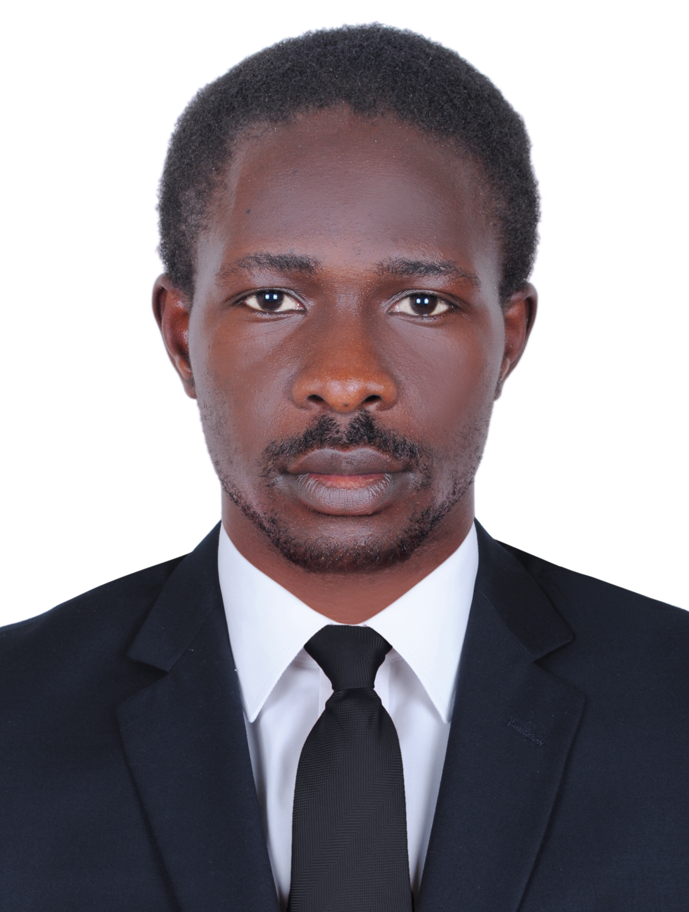
Ernest
Al Baada, Dubai St 45, Villa1
Nationality : Cameroonian
Marital status : Single
Languages : English and French
E-mail : Ernest.332933@2freemail.com
Visa status : Employment visa

POSITION: I.T NETWORK AND SECURITY SYSTEM TECHNICIAN

OBJECTIVE:
I would like to pursue a challenging career and strive hard to acquire Organizational Goals and achieve higher grounds in the ever growing and innovative field of Information technology.

PROFILE:
Total Three years and Five months of experience in the field of Information Technology in the area of Network & System Administration on Windows 2008/2012, cisco systems, Ubiquity Networks, Linux Firewall and hotspot systems (Mikrotik Pfsence ) , security systems, IP telephony systems ( Avaya, Yester, Sipxecs and Elastix) , Biometric Access Control , CCTV systems and modern Internet Technology (I.O.T) .

MY STRENGTH
Fast learner, self-motivated, applying methods and technical updates in my day-to-day work with a high degree of attention and commitment to work.
More so I am Eloquent in speech and posses high and exceptional communication skills for better customer relationship and management.

MY EXPERTISE :

 Installation, maintenance and configure CCTV camera system and Biometric access control systems
 Installation, configuration and administrating Asterisk VoIP PBX networks
 Installation, Configuration and Administration of Cisco Routers and Switches
 Administering, configuring and troubleshooting of Windows 2012/2008/2003/win7/XP, and UNIX
Based Operating systems
 Excellent PC maintenance skills
 Excellent understanding and experience of TCP/IP based networks
 Very well acquainted with various networking tools
 Communication and team building skills with ability to work independently or in a team
 Excellent skills and experience in cabling networks using UTP CAT5E CAT6 and CAT7
 Excellent technical and provisory skills involving Installation, maintenance and troubleshooting
 Excellent in identifying and troubleshooting of minor & critical problems occurring on the Network
 Excellent at drafting Troubleshooting and day to day procedure
SERVICES RENDER IN LEGEND I.T UAE (CURRENTLY WORKING) :

 Onsite network and security systems technician
 Internal Hardware and Software Technician
 I.T sales personnel

PROJECT CARRIED ON WHILE WORKING WITH LEGEND I.T :

 Network installation with structured cabling at Kuwaiti Consulate Bur Dubai
 Installation and configuration on windows and routers in customers villas and homes
 Repair of both laptops ,desktop and CCTV installation and online configuration for remote mobile viewing in both legend I.T and on outstation.
 Installation of CCTV at Ritaj DIRC (Dubai investment real estate company) and Door access control and barrier system at al Mozna community center at Al Qusais Dubai

SERVICE RENDERED TO FLEXCOM TECHNOLOGIES , KEDAG COMPANY LIMITED AND EVERGREEN IT CENTER 2013 -2015 :

 Installation, maintenance and configure CCTV camera system, biometric access control and fire alarm systems
 Installation, configuration and administrating Asterisk VoIP PBX networks
 Installation, Configuration and Administration of Windows 2003/2008 File and Print Servers
 Installation, Configuration and Administration of DNS Server and DHCP Server
 Installation, Configuration and Administration of Terminal Services and Remote Desktops
 Installation, Configuration and Administration of Web Servers (IIS and Apache)
 Administering and auditing Security of Systems and Network Resources
 Installation, and configuration of internet hotspot, firewall system with mikrotik routerOS
 Managing Data Backups and Restores
 UPS and Printer Management.

Educational Qualification:
 GCE Ordinary and advance level
 National Diploma in network maintenance
 National Diploma in computer hardware maintenance

OTHER TRAININGS AND ADD-ONS

 CCNA yet to Certify
 UNIX Administration - Sun Solaris & Red Hat Linux
 Web Technologies – HTML, DHTML, JavaScript, PHP
 GIS/GPS Fleet management and tracking system

Reference :
I will provide all reference upon request.

Remark :
I Hereby accept that all that is Written Here is True and I Take Responsibility of it.

