Dr. Gopalkrishna
Gopalkrishna.332934@2freemail.com
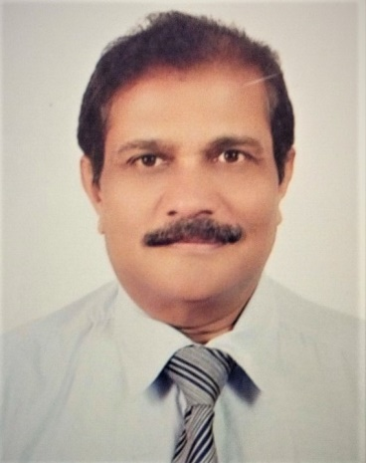

Position : General Practitioner
May 2015 to December 2016
OPD, ER, In Patient and Orthopaedic Department
Medeor 24x7, Abu Dhabi U.A.E.

Summary:
My recently held position was, GP looking after the outpatient, in patient, emergency as well as the orthopaedic department in Medeor 24X7. I have served as a Senior Surgical House Officer for over 14 years with experience in the Orthopaedic Department at SKMC Medical City, Abu Dhabi. Abundant experience in emergency orthopaedic management and outpatient consultation coupled with past experience in General surgery and Radiology showcasing my familiarity with a wide spectrum of disorders and treatment modalities. I am also adept in handling administrative tasks and an active contributor to training new staff. I am extremely comfortable working in a multicultural setting and fluent in multiple languages including Arabic

Work Experience
- May 2015- Dec 2016 : General Practitioner at Medeor 24X7
- Jan 2000 – Jan 2015 : Sr. Surgical House Officer at SKMC, Abu Dhabi
- Aug 1995 – Dec 1999 : Assistant Surgeon Orthopaedic Full time to Dr. PN Shah, Mumbai
- April 1992- March 1995 : Part time Asst. Surgeon to Dr. PN Shah, Orthopaedic Surgeon,
Mumbai
- April 1991 – March 1995 :Part time Asst. Surgeon to Dr. Suresh Joshi, CVTS Surgeon,
Jaslok Hospital Mumbai
- May 1991- July 1995 :Medical Officer at Occupational Health Canter, Modistone
Ltd. Mumbai
- Dec 1986 – March 1991 :Resident Surgeon At Sodha Hospital Mumbai
- March 1985 – Dec 1986 :Resident Medical Officer Cumballa Hill Hospital, Mumbai.

Education & Qualification :
- Jun 1979 to Oct 1983: D.M.R.D: Topiwala National Medical College, Mumbai, India
- Jun 1972 – Dec 1976: M.B.B.S, Mahadevappa Rampure Medical College, Gulbarga, India

Residency & Training :
- Jan 1977 – Mar 1978: Internship: Government General Hospital, Gulbarga, India
- Mar 1978 – Feb 1979: General Practitioner at home in Gangawati, Karnataka, India
- Feb 1979 – Mar 1985: House Officer in various surgical specialities in Mumbai, India

General Surgery
- RN Cooper Municipal Hospital : 1979
- Bhabha Atomic Research Center Hospital : 1981
- LTMH Municipal Hospital : 1982
- Mahatma Gandhi Memorial Hospital : 1984

Orthopaedic Surgery
- RN Cooper Municipal Hospital in 1979 -1980
- Santacruz Municipal General Hospital in 1980

Pediatric Surgery
- K.E.M Municipal Hospital 1981-82

Radiology
- K.E.M Municipal Hospital 1980-81
- Bhagawati Municipal Hospital in 1984

Cardiovascular Thoracic Surgery
- Jaslok Hospital & Breach Candy Hospital 1991- 92
- Registrar

General Surgery
- Kasturba Hospital & Minor Surgery
- BYL Nair Hospital 1983- 1985
- As Trauma Research Scholar at LTMG Hospital 1982- 1983.

Teaching Experience
- As a Minor Surgery Registrar at BYL Nair Hospital – Teaching Interns from Topiwala National Medical College
- At SKMC Abu Dhabi – Conducting lectures for nurses, physiotherapists and ER Physicians

Licensure & Medical Council Registration:
- Karnataka Medical Council, India 1978
- Maharashtra Medical Council, India – 1979
- Medical General Practitioner Licensure, HAAD, Abu Dhabi – 2000

CME & other courses:
- Regular Weekly surgical Rounds held at SKMC, Abu Dhabi
- Regular Weekly Orthopaedics Departmental X- ray rounds
- Monthly Abu Dhabi Orthopaedic Club Meetings
- Monthly Orthopaedic Departmental Journal Club Meetings
- Taylor Spatial Frame Course conducted by SKMC, Abu Dhabi in Jan 2002
- AO Basic Fracture Treatment Course held at Dubai in Jan 2004
- ATLS Basic Course for Doctors held at SKMC, Abu Dhabi in Sept 2006
- Orthofix External Fixator held at Abu Dhabi in Nov 2006 and Nov 2008.
- Attended ACLS certification course.

Other activities and positions held:
- Hon. Divisional Surgeon to Pheonix Division of St. John Ambulance in 1998- 2000
- Yoga Training course from Karnataka University, Dharwad in 1975
- National Cadet Corps, Military Training Certificates A & B of Indian Army
- Represented the College in inter Medical Youth Festival & Inter Med Sports
- Took part in Stage Dramas and singing events during my college career.

