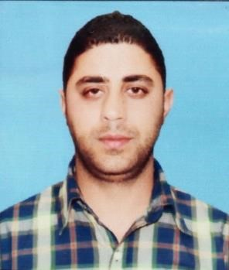

Shaahid
Email id – Shaahid.332937@2freemail.com

Objective: -

Enthusiastic to enroll myself in a challenging and growth oriented esteemed Organization in sales domain, where I can use my skills for the growth of the organization and as well as achieve professional growth.

Work Experience:

Company Name Ansari Toyota
Duration 10 June 2008 – 30 Sep 2016
Designation Senior Sales Manager
Country J&K India

Responsibilities –

- Plan and execute such strategies as to ensure that the budgeted target for showroom is achieved or exceed in volume and profit term.
- Communicate sales plan and target to the sales team to achieve targets successfully.
- Deal with critical problems, major customer complaints or issue that may be escalated and ensure prompt action or decision for timely resolution
- Interact regularly with the existing and prospective customers to establish profitable relationship and determine their present and future requirements.
- Maximize usages of Demo’s and monitor Demo to sale ratio.
- Manage all aspect of the showroom to ensure high standards in the display, housekeeping and product information to convey the desired image of the brand and the company.
- Respond to telephone and in-person requests for information.

Company Name K C Hyundai Pvt.Ltd.
Duration 14 March 2004 – 30 April 2008
Designation Senior Sales Consultant
Country J&K India

Responsibilities
- Figure out customer’s needs by listening and asking questions.
- Ensure that customers understand the vehicle’s operating features, safety features, paperwork, service& Maintenance and warranty
- Close sales by overcoming objection(s); complete sales or purchase contracts; explain provisions; offer services, warranties and financing; collect payment and deliver automobile
- Perform walk-around with new and old customer and demonstrate features of suitable vehicles
- Participates in sales meetings and training provided by the dealership and manufacturers
- Close sales by overcoming objection(s); complete sales or purchase contracts; explain provisions; offer services, warranties and financing; collect payment and deliver automobile.
- Assisting Clients during test drives.

Education
- Diploma Mechanical Engineering from SSM college of Engineering parihas pora Pattan Srinagar J&K India 2000-2003
- High School from State board of school education Srinagar 1999

Skills
 Determination  Active listener  Enthusiasm  Flexibility  Customer Service Skills  Teamwork &
Supervision  Quick learner  Problem Solving

