Joseph
Joseph.332955@2freemail.com
03rd of Sept. 1982, Philippines

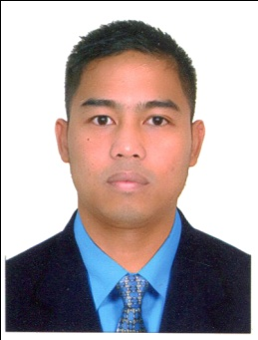

Work in stable company where my skills and potentials would be developed to provide valuable contributions to the company. I am looking for a career that is both challenging and rewarded.
EMPLOYMENT DETAILS:
COMPANY:CARAMEL CENTER LLC | ADDRESS: BOTANICA TOWER, JBR DUBAI MARINA
JOB TITLE: CASHIER/MERCHANDISER | APRIL 2013 TO MARCH 2016

OVERALL RESPONSIBILITY FOR THE COMPANY:
- Smile and greet the customer.
- Checking daily cash account.
- Guiding and solving queries of customer.
- Providing training and assistance to new joined cashier.
- Maintaining monthly, weekly, daily report of transactions.
- Removing any expired or damaged product.
- Replacing product.
- Meeting with the store managers for reordering product.

COMPANY: ALMARAI COMPANY LTD. | ADDRESS: P.O. BOX 8524 RIYADH 11492 K.S.A.
JOB TITLE: STOREKEEPER/MERCHANDISER | APRIL 05, 2011 TO APRIL 06, 2013

OVERALL RESPONSIBILITY FOR THE COMPANY:
- To exercise general control over all activities in stores department.
- To ensure safe keeping both as to quality and quantity of materials.
- To maintain proper records.
- To initiate purchase requisitions for the replacement of stock of all regular stores items.
- To check and receive purchased materials forwarded by the receiving department.
- To reserved particular material for a specific job when so required.
- Analyzing past sales figures/trends to anticipate future product needs.
- Devising a merchandise plan using the above techniques.
- Relaying the merchandise plan to buyer who in turn can decide on what products, styles, etc.
- Devising a contract for the suppliers including quality control, accuracy and flexibility.
- Allocating certain amounts of stock to each outlet throughout the season.
- Monitor stock movement consider markdowns inter-branchtransfer promotions.
ACADEMIC BACKGROUND:

Tertiary Education: | West bay college | Year 2003 – 2004
Marine engineering
Secondary Education: | San Pablo City National High School | Year 1999 – 2000
Primary Education: | San VicenteElementary School | Year 1995 – 1996
PERSONAL PARTICULARS
Nationality | Filipino
Gender | Male
Marital status | Married
Height | 5’4”
Weight | 110lbs
Language/Dialects | English/Basic Arabic
Visa status | Visit visa

SKILLS:
- A flexible who enjoys learning new skills and quickly adapts organizational changes
- Can work as a part or a team or alone
- Ability to manage multiple task simultaneously
- Confident attitude with active approach to work
- Able to prioritize individual workloads according to deadlines
- Willing to long work accustomed hours
- Good moral
- Computer Literate
- Driving

I HEREBY CERTIFY THAT THE ABOVE INFORMATION IS TRUE AND CORRECT TO THE BEST OF MY KNOWLEDGE.

