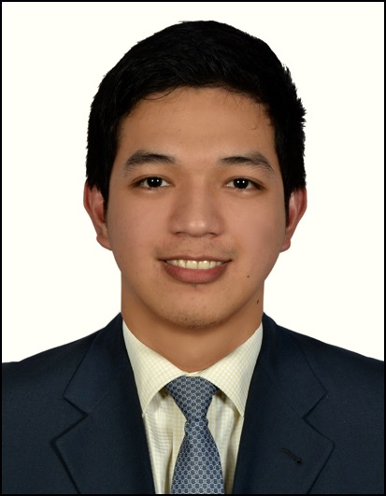
Mardy, IMT (ASCP)
Mardy.332960@2freemail.com

Medical Laboratory Technologist

Clinical Microbiology
Serology
Phlebotomy
Clinical Chemistry
Hematology
Clinical Microscopy
Point of Care testing
Immunochemistry

Degree: BS Medical Technology, University of Santo Tomas

WORK HISTORY
Medical Technologist June 2016-November 2016
CHI-St. Alexius Health Williston Medical Center (North Dakota, USA)

- Performs simple and complex tests in Hematology and Clinical Microscopy.
- Performs serological testing and process samples in Microbiology.
- Performs Phlebotomy
- Performs quality control on machines
- Performs routine and complex Blood Banking procedures.

Medical Laboratory Technologist July 2013- May 2016
American Crescent Healthcare Center (Abu Dhabi, UAE)

- Generalist, performs tests in Clinical Chemistry, Hematology, Clinical Microscopy, Serology and Immunochemistry
- Performed blood and other sample collections
- Operated different machines such as Cobas 6000, Cobas e411, Cobas c311, Swing and Saxo (blood grouping), Sysmex XT-2000i, Cobas 6500 and Urisys 2400
- Maintained lab instrument and troubleshoot/ resolve any Instrument problems
- Performed quality control and external quality assurance

Medical Technologist (Microbiology and Serology) March 2012- April 2013
Makati Medical Center (Makati, Philippines)

- Processed over 500 samples for routine and special bacterial, fungal and mycobacterial testing per week
- Performed quality control on machines and culture media
- Processed blood and body fluids samples for Serological testing
- Maintained a safe and clean working environment by managing waste disposal in accordance with MMC’s established procedures.
- Monitored stocks and inventory of reagents
- Validated and released results

Medical Technologist (Outpatient and Emergency Room Laboratory) Jan2011-Feb 2012
Makati Medical Center (Makati, Philippines)

- Performed blood collection and other sample collection on over 500 patients per week
- Trained newly hired staff medical technologists and nurse phlebotomist on phlebotomy and using the Laboratory Information System
- Performed point of care testing on the Emergency Room Laboratory
- Awarded as “one of the top 30 most commended employee” by the patients in the hospital (2011)
- Awarded for commended performance in handling patients by the Pathology and Laboratory department (2012)
EDUCATION

Bachelor of Science in Medical Technology, University of Santo Tomas, Philippines (2010)

LICENSES /CERTIFICATIONS

Health Authority Abu Dhabi, Medical Laboratory Technologist 1 2013- present

American Society for Clinical Pathology, Medical Technologist 2011- present

Professional Regulation Commission (Philippines), Medical Technologist 2010- present

