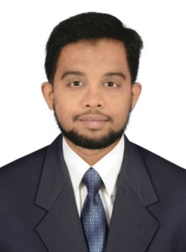
Abdul
Abdul.332962@2freemail.com

Objective
Being a young, aspiring and ambitious Designer, I am looking for an organization that offers a challenging, stimulating and learning environment to work in and provides scope for individual development and career growth.

Key Skills
  - Having knowledge in the Adobe Illustrator, Adobe Photoshop, Adobe InDesign. coral raw
  - MS Office (with proficiency in PowerPoint presentations)
  - Adobe PDF Editing
  - Excellent IT skills, especially with design and photo-editing software
  - Exceptional creativity and innovation
  - Excellent time management and organisational skills
  - Accuracy and attention to detail
  - An understanding of the latest trends and their role within a commercial environment
  - Professional approach to time, costs and deadlines
  - Ability to work on a Mac or Windrows 10

Work Experience
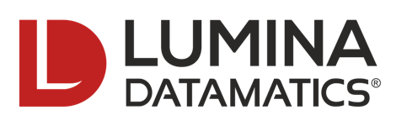
Organization : Lumina Datamatics
Designation : Creative designer ( Executive )
Period : Since November 2014 to October 2016.
Location : Chennai, Tamil Nadu, India

Roles and Responsibilities:
- Meeting clients to discuss their needs, objectives and budgets.
- Designing and creating a wide variety of graphic art and promotional material.
- Producing designs for both internal and external communications.Involving customers in the design process.
- Creating integrated design projects across both business card and pamphlet outputs.
- Developing design briefs.
- Explaining design concepts and ideas to clients and colleagues.
- Coordinating multiple publishing projects.
- Commissioning illustrators and photographers.
- Working on presentations, leaflets, trade-marks, marketing materials and banner designs.

Organization : Mediaserve Solutions Private Limited
Designation : Creative designer ( Executive )
Period : Since january 2012 to June 2014.
Location : Chennai, Tamil Nadu, India

Roles and Responsibilities
- Managing, producing and designing projects from brief to fulfilment.
- Designing & creating marketing & e-marketing materials on a range of projects.
- Ensuring consistency in a clients corporate and promotional brands.
- Presenting finalised ideas & concepts to clients, colleagues and senior managers.
- Answering queries from clients. Creating original artwork for short and long term projects.
- Involved in designing advertisements, brochures, handouts, flyers and online graphics.
- Working with a range of media, including photography, to create final artwork.
- Designing pitches and presentations for the sales teams.
- Client Deepetch
Educational Qualification
Bachelor of computer application 2016 passed out, Tamil Nadu open university Chennai

Diploma in Digital visual media animation & visual effects, 2011 passed out, Image Multimedia Trichy.

Higher Secondary School kumbakonam passed out in 2008

Certification
- Microsoft-Office
- Autodesk 3ds Max
- Hardwar (CSC)
Strength

- Dependable team player and able to work independently.
- Fast learner, pro-active, highly organized and flexible to changes.
- Can perform well under pressure and meet deadlines.
Hobbies
- Playing Games
- Listening Music
- Gardening

Personal Info
Date of Birth : 17.10.1990
Gender : Male
Nationality : Indian
Language Known : English, Tamil
Visa Status : Visit (UPTO FEB 25th)

Declaration
I hereby declare that the information furnished above is true to the best of my knowledge and I assure that I can give my best efforts for the progress of the company.
Yours truly

