CURRICULUM VITAE

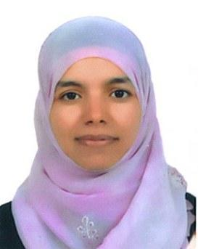

SIHEM

E-mail: SIHEM.333015@2freemail.com

Position desired: RADIOGRAPHY TECHNOLOGIST

OBJECTIVE

To pursue a challenging and growth oriented career in an organization that provides opportunities to learn and develop.

SKILLS
- Strong ability to effectively manage multiple complex tasks simultaneously and coordinate time effectively
- Able to identify issues and problem area and form innovative solution
- Perform all routine and complex studies in MRI,CT,Xray
- Specialized in musculoskeletal studies
- Able to do all cases including Brain ,spine, abdomen ,musculoskeletal
- Able to do all types of X-ray ranging from standard imaging, portable, emergency, fluoroscopy and Mammography

ACADEMIC QUALIFICATIONS

- Obtained the baccalaureate in Science Experimental in 2006 in TUNISIA
- Diploma in Medical Imaging and Radiotherapy at the Higher School of Sciences and Technology of Health in Tunisia in 2009( From September 2006 To June 2009)

EXPERIENCE

- Radiographer at Exeter Medical Centre for bone and joint health in Abu Dhabi for 2 years from October 2014 to October November 2016
- Radiographer at governmental hospital from June 2013 To November 2013 in Jendouba- Tunisia
- Radiographer at Imaging Medical Center for 3 years from march 2010 to june 2013 equipped with DR x-ray machine,Simens MRI machine1.5 Tesla,Mammography and dental panoramic -TUNISIA
- Trained in University hospitals such as Charles Nicolle, Habib Thamur,Rabta and Salah Azaiez hospitals( nursing for 1 year, CR and DR x-ray machines, CT scan and MRI)

PERSONAL INFORMATION

- MS OFFICE: Good
- RIS: odDate of birth : May 6,1987
- Marital status: married
- Nationality: Tunisian
- Gender : Female
- Visa status: Husband visa

COURSES AND CONFERENCES

- Basic life support 2015
- Arab health congress 2015
- Healthcare Recruitment and Training Fair Congress 2016 (Imaging & Radiology Conference 2016
PERSONAL QUALIFICATIONS

- Team skills
- Self-motivated ,excellent communication skills ,honest and truthful
- Active during duty and always helpful. Hardworking and can efficiency work under pressure.
- Professional in creating good relations with all Nationalities
- Have the ability to handle all problems and how to penetrate it and find a good solution to be satisfied to everyone.

- Greeting patients.
- Giving the appropriate information.
- Oriented them to the correct way.
- Protection patients and applying radiation protection policies
- Excellent in patient management and safety

LANGUAGE

- Arabic: Mother tongue
- English: good
- French: very good

For more information please don’t hesitate to contact me at my Email or Number mentioned above.

