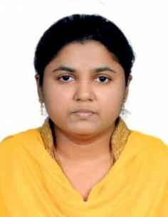
BOMMI
BOMMI.333028@2freemail.com

Work Experience
Worked as office Assistant for two months in GoodNews Channel Pvt ltd, Chennai
Objective
Seeking a challenging position in a leading organization, where my qualifications can be utilized to deliver Corporate results-besides enhancing my career prospects with the organization.
Education –Professional Qualifications
2001-2003 Master Of Business Administration Park’s College (India)
1999-2000 Post graduate Diploma Computer Applications Bits Information Technology (India)
1996-1999 Bachelor of Business Management Oxford College of Business Mgt (India)
1994-1996 Higher secondary Indian High School (Dubai)
Project and Research
Master of Business Administration-Employee Safety and Security (2002-2003)
Bachelor Of Business Management-Budget Preparation, Review and Estimates ( 1998 -1999)
Post Graduate Diploma in Computer Applications- Computerized Banking system (1999-2000)
working experience in u.a.e
worked as a receptionist cum Computer operator at samra electrical trading company in fujairah from 2013 June till 2014 september
Achievements
Project Report in M.S. Office
Participation Certificate in Case Analysis
Proficiency Certificate in Human Resource Development
Proficiency Certificate in Promotion Management
Gulf Mathematics Olympiad

Computer skills
Working knowledge of MS Office 2007(Outlook (Email), Word, Excel, PowerPoint)
Personal qualities
Diligent, reliable and trustworthy
Team player
Effective communication and interpersonal skills
Personal information
Date of Birth : 25 July 1978
Marital status : Married
Nationality : Indian
Language capabilities : English, Hindi, Tamil
Visa status : Visit Visa-Expiry date: 10January2017
Availability : Immediate

Interests and Activities
Organizing conferences, seminars, events

