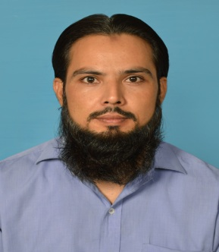
Engr. Hafiz
Hafiz.333032@2freemail.com
OBJECTIVES:
To enhance my knowledge and capabilities by working in a dynamic organization that prides itself in giving substantial responsibility to new talent.
PERSONAL PROFILE:
- To enhance Critical thinker - strong analytical skills.
- Self-aware - always seeking to learn and grow
- Well-organized, good planner; good time-manager
- High integrity and honesty, ethical and socially aware
- Emotionally mature - calming and positive temperament
- Have studied Engineering Ethics, Engineering Management and Engineering Economic as elective courses.
- Functional Areas: Electrical &Electronics and Computer Hardware
QUALIFICATION:
- BS Electrical engineering
- DAE Electronics
- certificate of Hardware and Software of Computers and Mobil
FINAL PROJECT:
Programmed by proton Basic for Design and implementation of intelligent Uninterruptible Power Supply(i-UPS). Totally based on microcontroller with interfaced LCD(20x4).
TERM PROJECTS:
Home auto mation,water level by micro controller,Power factrol control device,Cell Phone call Detector (CPD), Flip Flop, Solar Tracker using servo motor, FM Transmitter, and Microcontroller based Traffic Light, Temperature controller and DC voltmeter.and many more
PROFESSIONAL EXPERIENCE AND ACHIEVEMENTS:
Creator of PEARL-LAB(Pakistan Electronics Advisor &Repairing Lab)
Control panel board .DB Dressing. Studio, 2 & 3 bedroom wiring according to Dubai standards
Computer Hardware and software and trouble shouting, well knowledge to handle measuring instruments,
Repairing of all kind of electronics, especially inverter, UPS, LAPTOP, desk top, HiFi sound systems, LED, LCD, power supplies and Players etc.

COMPUTER SKILLS:
- Proton Basic, Pspice, MATLAB, Proteus ,
- Microsoft Office( Word, Power Point, Excel )
- Windows Installation and Hardware(DOS)
- window 98, 7, 8, 10
- C/C++ Programming, Java, Assembly language.
HOBBIES AND INTERESTS:
Technology, Circuit Designing, Electronics Projects, Teaching and helping people, Use Computer for advanced searching.
Circuits Diagnostics. Circuits Analysis etc.

