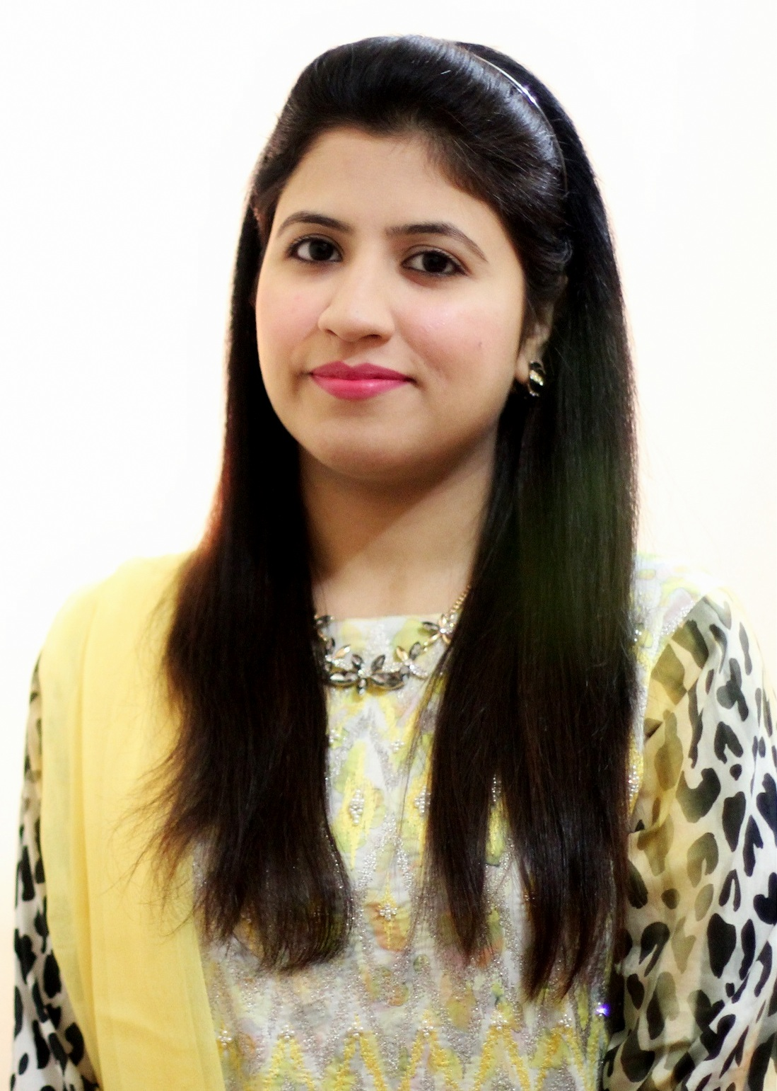Tahmina

Tahmina.333068@2freemail.com

Objective:
My objective is to work in a versatile and effective learning environment, where I can groom myself to the fullest. I am a “Lifelong Learner” and I believe learning at any age of stage of life is an essential part of being true to ourselves. I always enjoy my work no matter what kind of job it is, being a loyal employee is always easy for me.
Work Experience:
- Content Writer at Upwork (aka oDesk)
From Jan, 2013 to Nov, 2016
- Teacher at Maroof Model High School
From Mar, 2014 to May 2016
- Administrative Assistant at Directorate of Faculty Development and Internationalization, Lahore College for Women University
From April, 2014 to Oct, 2014
- Creative development Executive at Together – Strategic Consultant Company
From Sep, 2013 to Jan, 2014
- Blogger at defendpakistan.com
From March, 2013 to May, 2013
- Intern at Centre for Career Counseling and Job Placement- Lahore College for Women University
From Feb, 2013 till April, 2013
- Intern at Noon Pakistan Limited
From July, 2011 till August, 2011
Education:
QUALIFICATION | YEAR | INSTITUTE | GRADE/CGPA
MS – Marketing | 2016 | IB&M – University of Engineering and Technology | 3.7
BBA (Hons.)  Specialization: Marketing | 2012 | Lahore College for Women University (LCWU) | 3.6
I.C.S  (Physics, Maths, Computer) | 2008 | Queen Mary College | A
Matriculation  (Physics, Chemistry, Computer) | 2006 | Knowledge House School System | A+

Diploma:

English Language Diploma from National University of Modern Languages (numl) in 2013, A+ Grade
Awards and Achievements:

- 3rd Position in MS - Marketing Course at IB&M, University of Engineering and Technology (2016)
- Merit Based Award – Prime Minister National Laptop Scheme (2015)
- Event coordinator for Global Conference – Next Generation Voices, organized by British Council and LCWU (2014)
- Event coordinator for Job Fair at LCWU (2013)
- Top scorer, Diploma in English Language at numl (2013)
- Merit Based Award – Prime Minister National Laptop Scheme (2012)
- Top scorer at Knowledge House School System - Secondary School Examination (2006)
Professional Skills:
- Microsoft Office (MS. Word, MS. Power Point)
- Excellent Communication and Writing skills
- Research skills
Personal Skills:
- Hardworking
- Team player
- Efficient
- Socialite
Lingual Proficiency:

- English
- Urdu

