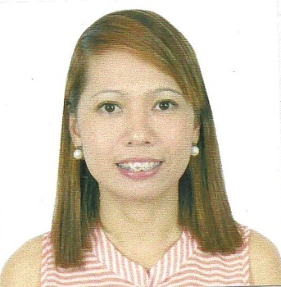
LEA
Date of Birth: August 3, 1981
Citizenship: Filipino
Email Address : LEA.333079@2freemail.com
Visa Status: Visit Visa

CAREER OBJECTIVE:

To seek new challenging assignment and responsibility, with an opportunity for growth
and career as successful achievements as well as self development and to excel in my field, to
obtain a position and responsibilities that utilizes my skills and experience, hence enhancing
my skill and knowledge and ready to learn new things.
WORK EXPERIENCE: Medical Receptionist
June 2015-Oct. 2016 Ibnsina Lab Sharjah

- Answers incoming calls and queries
- Register out patients and samples from clinic
- Relay reports to the doctors
- Performing laboratories work
- Collecting blood from patient
- Maintain the reception in waiting area in an orderly state at all times
- Handling daily cash tally for clinics and outpatient payments

WORK EXPERIENCE: Accounts Assistant/Administrative Assistant
May 2013-May 2015 Probikes Motorcycle Center-Philippines

- Answers incoming calls and queries
- Performs administrative and clerical works
- Assists the branch manager with all the stock taking, guest complaints and sales
- Handles the daily cash budget and performs cashiering duties
- Ensures payments from customers are collected promptly and as due comes
- Prepares daily weekly and monthly collection reports
- Makes and arranges collection schedules

Jan 2010-Jan 2012 Med Tech Assistant
Ligao Clinical Laboratory-Philippines

- Help assist the medtech in laboratories work
- Performs the blood test of the patients
- Relay results to the doctors
- Handling cash for outpatient payments

Jan 2007-Dec 2009 Administrative Clerk
Ligao Community College-Philippines

- Answers all incoming calls and queries reservation and queries of students, parents visitors, etc
- Performs administrative and clerical activities
- Assists the manager for maintaining records of activities
within the department

Jan 2006-June 2006 Administrative Clerk
Boy Scout of the Philippines-Philippines
- Answers telephone calls and queries
- Performs administrative and clerical activities
- Assists the Manager for maintaining records of activities within the department

EDUCATION

June 1999-December 2005 Bachelor of Science in Medical Technology
Ago Medical Educational Center- Philippines

June 1995-March 1999 Secondary Education
St. Mary’s Academy-Ligao City-Philippines

SKILLS /ABILITIES
Computer/System Skills Proficient in Microsoft packages such as Microsoft Word, Excel, Powerpoint Outlook

Typing Skills 55 Words per minute

Language Skills Fluent in Oral and Written English
Fluent in Oral and Written Tagalog

