CURRICULUM VITAE
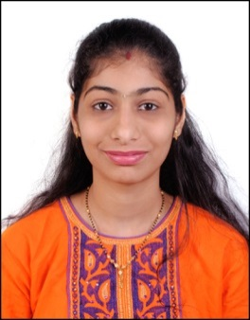
DHARTI
EMAIL: DHARTI.333121@2freemail.com

CAREER OBJECTIVES:
To obtain a challenging role in Retail market and Customer service industry which will utilize and further develop my problem solving skills, analytical skills, and leadership skills to provide its optimum and provide high level satisfaction to Customers and employer.

SPECIALIST SKILLS:
- Excellent customer service, public relations, selling skills.
- Demonstrated ability to communicate with and relate to people at all levels.
- Knowledge of Workplace Health and safety standard.
- Strongly believe in TEAM WORK.

ACADEMIC CREDENTIAL:
- M.Com (Part 1) from Mumbai University – Pass
- M com ( part 2 ) appeared in 2016
T Y B.com (Bachelor Of Commerce) PASS Mumbai University M.K. College 76%
- H.S.C. (High secondary Certificate 10+2) PASS Mumbai University M.K. College 74%
- S S C ( secondary school certificate ) 10 Mumbai University69.60%

COMPUTER SKILLS:
- MS Office, Fox ,Tally.
- All Operating System Efficient In Internet.
- DGA –Diploma in Graphic & Accounting Course in Computer.

PROFESSIONAL EXPERIENCE IN INDIA:
Company | Post | Duration
Axis Bank India | Retail sales credit card | Jan 2014 To Current 2015

Office Administration :

- Answer phones and operate a switchboard.
- Route calls to specific people.
- Answer inquiries about company.
- Greet visitors warmly and make sure they are comfortable.
- Call persons waiting for visitor and book them a room to meet in.
- Schedule meetings and conference rooms.
- Coordinate mail flow in and out of office.
- Coordinate office activities.
- Hand out employee applications.
- Arrange appointments.
- Send email and faxes.
- Collect and distribute parcels and other mail.
- Perform basic bookkeeping, filing, and clerical duties.
- Update & Schedule appointment calendars.

STRENGHTS:
- Capable of Handling Responsibilities and Ability to Work with team under pressure.
- Excellent Communication, Presentation Skills.
- Honesty, Integrity, Hardworking, Punctual Confident and Determined Approach.

PERSONAL DETAILS:
Date of Birth : 23 APRIL 1992
Sex : Female
Civil Status : married ( 2 Jan 2016)
Nationality : Indian
Languages : English, Hindi, Marathi & Gujarati

PASSPORT DETAILS
Place of Issue : Mumbai
Date of Issue : 13/04/2016
Date of Expire : 12/04/2026
Visa Status : 1 JANUARY 2017
Visa Valid Until : 1 APRIL 2017

DECLARATION:
I, Asher hereby declare that all the information furnished above is true to the best of my knowledge.

