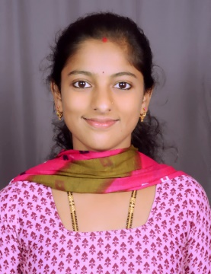

**SUCHITHRA**

[**SUCHITHRA.333163@2freemail.com**](mailto:SUCHITHRA.333163@2freemail.com)

**Career Objectives**

After having worked with Well-established firms, which has further inspired me to enhance and develop by abilities, I further wish to gain added valuable experience, providing my support and experience to my employer, in exchange for a stable and well respected career plan.

**PROFESSIONAL EXPERIENCE:**

**CUSTOMER SERVICE IN JUSTBOOKS (2015-2016)**

* Use to handle front desk members those who come for new membership plans and explain about those plans and procedure.
* Use handle store when managers is in absence.
* Use to help members indeed of their books quickly.
* Use to send day by day transactions details to store manager.
* I was handling member’s problems face to face and sometimes through calls.
* JustBooks is a new generation community library chain that provides a unique reading experience to book lovers with a wide range of books for every type of reader
* Helpdesk /Customer service / Telecalling

**Academic Qualification**

* Sanjay Memorial Polytechnic

Diploma in Electronics & Communication Engineering (2012-2015)

Sagar, Karnataka

* Sagar Pre-University College

PUC In Science (PCMB) (2010-2012)

Sagar, Karnataka

* M.G.N.PAI. High School

SSLC (2010)

Sagar, Karnataka

**Key Skills**

* Basic computer knowledge
* Ms word, Ms excel, Ms PowerPoint & Tally with VAT
* Ability to inspire creativity among team members

**Personal details**

D O B : 01-01-1994

Marital Status : Married

Nationality : Indian

Languages Known : English/Hindi/Kannada/Telugu

Visa Status : Residence

**Personal Strength**

* Disciplined, Honest, Punctual and Hard Working
* Can work under pressure
* Pleasing personality, friendly and co-operative attitude