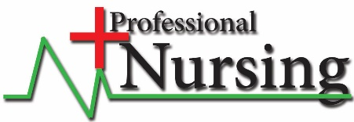
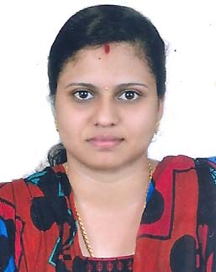
curriculum Vitae
swathy
Email : swathy.333186@2freemail.com
Personal Profile
i am looking for position where my skills and creativity can be effectively utilized. my experienced knowledge gives me the confidence to be competent and effective which allow me to work in different application areas with high commitment and carefulness.
Academic Qualification
B.SC Nursing 2013 | 70%
Dr.NTR University sri Venk ateswara college of Nursing kakinada. Andhra pradesh. india
Higher Secondary +2 2009 | 72%
Kerala State Sylabus SNDP HSS.Caramveli india
SSLC 2007 | 60%
CBSE Sylabus Carmel convent English medium school Thadiyoor indai.
Subjects Studies
1st Year
a) Nursing Foundation
b) Nutrition and Biochemistry
c) Microbiology
d) English
e) Anatomy & Physiology
f) Psychology
2nd Year
a) Community Health Nursing 1
b) Sociology
c) Medical Surgical Nursing 1
d) Pharmacology Pathology & Genities
e) Communication Educator & Technology

3rd Year
a) Mental Health Nursing
b) Medical Surgical Nursing 11
c) Child Health Nursing
4th Year
a) Community Health Nursing 11
b) Principles of Management including Management
c) Nursing Research methods projects
Seminar & Training Attended
SEMINAR ON
(A) Diabetes Mellitus
(B) Congenital Disorders
(C) Nephrotic Syndrome
(D) Attended regular in - Service educational classes
(E) Breast Feeding Technique
Procedures Performed
• Sponge Bath
• Bed Making
• Vital signs
• Monitoring Intake | Output
• Care of patients with ventilator
• Administer medication | Injections
• IV line insertion
• Preparing patients for surgery
• Care of post operative patient
• Tracheostomy care
• Recording & Reporting
About The Hospital
Government General Hospital & international Health Care Kakinada, is a 1085 bed capacity hospital , Centre of excellence providing healthcare services in the ares of Audit | Pediatric cardiac Care, Reproductive medicine, Liver and digestive diseases and multi-organ transplantation. The Government General Hospital has superlative infrastructure, leading edge technology, most modern and state of the art facilities by a team of experienced specialists, nurses and paramedical staff, all under in one roof.
The Hospital at Kakinada-Andhra Pradesh has more the 1085 beds, 11 opearation theatres for institute of cardiovascular diseases, 2 state of the art cineless cath labs bedside a host of other facilities. The coronary care unit (CCU) is 16 bedded and fully equipped to deal with all cardio vascular emergencies.
The hospital has a total of 74 critucal care beds to provide intensive care to patients after surgery or angioplasty, emergency admission or other parents needing highly specialized range of investigative tests in the field of Nuclear medician, Radiology, Biochemistry, Hematology, Transfusion medicine and microbiology.
Surgical
Adult intensive care unit
A 20 bedded close surgical intensive care unit with both centralized and room telemetry monitors case includes, CABG, mitral valve replacement, COPD, congestive heart failure, Brachial asthma, chronic reral failure, myocarditis, cadiac arrhythmias, diabetes mellitus, Cyanotic and cyanotic condition, F.g TOF, ASD, VSD, Aortic and pulmonary stenosis.

Professional Experience
STAFF NURSE
Worked as a Staff Nurse in Susrutha Hospital Kerala from 22th October 2013 to 4th February 2016.
Professional Nursing Qualification
• Category Nursing & Midwifery and professional Registered Nurse - Abu Dhabi United
Arab Emirates.
Online Exam HAAD passed 7th June 2016 | Application No AGN161838 | Exam Id - 4519
Personal Details:
Date of Birth : 3rd Nov 1990
Nationality : Indian
Gender : Female
Religion : Hindu
Marital status : Married
Visa Status : Visit Visa
Professional Software:
•MS-Word
•MS-Excel
•MS-Power Point
•Internet Surfing
•Emil | Fax
•Scanning | Printing
Languages Know:
•English
•Malayalam
•Hindi
•Telugu
Professional Skills:
•Quick Learner
•Team Player
•Flexibility
•Honesty
•Problem Solving
Declaration
i hereby that all these statements made above are true to best of my knowledge mind belief.
Thank you,

