CURRICULUM VITAE

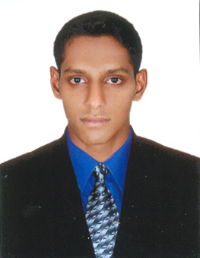
HAREES
CUSTOMER SERVICE EXECUTIVE

Email: harees.333193@2freemail.com

OBJECTIVE:

Seeking a challenging position and to contribute my skills and knowledge of company’s success and to gain growth and stability.

EDUCATIONAL QUALIFICATIONS:

- Diploma in Aviation Hospitality & Airport Management (IATA/UFTAA - Foundation Course)
- Bachelor of Commerce Degree
(University Of Calicut, Kerala, India.)
- Plus Two
(Board Of Higher Secondary Exam Govt. Of Kerala, India.)

EXPERIENCE:

- One month Airport training at Calicut International Airport, Kerala
- Six months experience in Akbar Travels of India Pvt. Ltd., Chavakkad as a Reservation and Ticketing trainee.
- Two year experience in Akbar Travels of India Pvt. Ltd., Guruvayoor as a Counter Executive

COMPUTER SKILLS:

- Computer Reservation System (CRS) - Abacus, Amadeus, Galileo
- M.S-Office.(Word & PowerPoint)

LANGUAGES KNOWN:

- Speak : English and Malayalam
- Read & Write : English, Hindi, Arabic and Malayalam

STREGTH:

- Good Communication Skill
- Positive Attitude
- Hard worker

HOBBIES:

- Travelling
- Playing Football

PERSONAL PROFILE:

Name : Harees
Nationality : Indian
Date of Birth : 10th May, 1991
Place of Birth : Kerala, India.
Sex : Male
Marital Status : Single
Religion : Muslim

PASSPORT DETAILS:
Date of Expiry : 29/08/2021
Place of Issue : Cochin
Visa status : Visit visa

Declaration:

In view of the above, I request you to be kind enough to give an opportunity to serve your esteemed organization in the capacity mentioned above, for which act of kindness. I shall be very thankful and grateful to you.

Place: Trichur
Date: 07/01/2017 Harees

