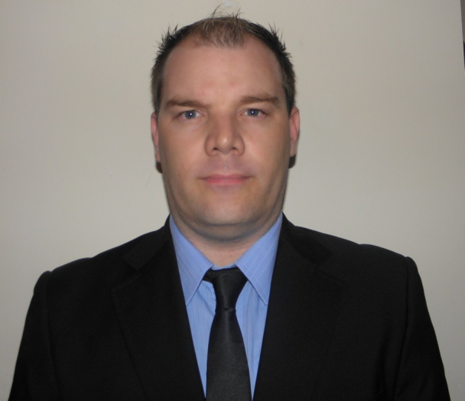

James
James.333199@2freemail.com

CAREER OBJECTIVE:
To be a part of your winning team and esteemed organization. Thereby affording me the opportunity to apply my skills in an effective manner enhancing the value I would bring to your company.

CURRENT WORKING EXPERIENCE:
Designation: Soft Services Manager of both the Burjuman Center (consisting of Burjuman Mall, Burjuman Residences and Burjuman Business tower) along with Reef Mall.
I am the incumbent of all Housekeeping, Pest Control and Recycling Projects on site.
Currently I have 176 staff reporting in-directly to myself through a team of Senior Supervisors, Supervisors, an administrator and Team Leaders.
My main duties amongst others are as follows:
- Ensuring all aspects of the department are run cost effectively and within allocated budget
- Making sure that departmental KPI`s are met.
- Managing all sites to the highest standards possible, with the assistance of a junior management team.
- Liaising with tenants, customers and suppliers as and when required
- Chairing of weekly and monthly meetings with subordinates
- Doing regular visits and inspections of staff accommodation
- Conducting probationary reviews before due dates
- Taking initiative in regards to in house training of staff for the betterment of the department
- Issuing disciplinary action to defaulting staff
- Attending weekly and monthly meetings along with Senior Management
- Suggesting of streamlined SOP`s where none existed in the past
- Implementation of revenue generating facilities (such as used cooking oil collection)
- Going to exhibitions as and when invited to do so, thereby getting exposure to the latest international trends in regards to the Soft Services industry.
- Identifying areas of improvement overall in regards to processes, facilities and staff.

My main achievements are:

- Initiating and implementation of cost effective alternatives to existing processes and facilities (related to chemical usage to enzyme based from INNU SCIENCES)
- Proposing of and initiation of trials of new products by third party contractors on site (DYSON AIR BLADE hand dryer with 5 year warrantee and free servicing),as opposed to previous element type (which was not energy efficient)
- Implementation of a colour coding system on site as per BICSc guidelines, to minimize the likelihood of cross contamination on various surfaces.

WORK EXPERIENCE:
Designation: Facilities Management Coordinator of the soft services department in the renowned Festival Center based at the Dubai Festival City Mall.

Job Description:
Responsible for ensuring that the highest possible standards are achieved and maintained in the mall by the third party contractors on site for all cleaning and sanitization activities, ranging from general cleaning activities, to waste management and pest control services as well as liaising with close to half a dozen service providers to achieve this in the following categories:
- Overall mall cleaning activities performed by the Transguard Group (including high level glass cleaning)
- Preserving AFGRE assets such as:
Maintaining excellent working condition of AFGRE boom lifts by our contractor Al Laith
Scaffolding.
- As well as the food court tray washing machines in excellent working order by our contractor Technical Supplies and Services Company (TSSC)
- All pest control activities (bird control) maintained by our contractor:Pest Free
- Removal of all recyclable goods from site by our contractor Union Paper Mills
- Ensuring that the entire manmade canal area is well kept by our service provider United Trading and Technical services Company (UTTC)

From: Dec 2013 to Present day

PREVIOUS WORK EXPERIENCE:
Emrill Services LLC

Designation: Area Operations Manager/Superintendent based in the world renowned Dubai Marina and responsible for over 240 indirect reports (Senior Supervisors,Supervisors,Team Leaders, Office boys and general cleaners) on more than a dozen sites. Prior to this I was based in the prestigious Down Town Dubai and also responsible for all cleaning activities on more than a dozen sites including the private offices of the Emaar Chairman at Emaar Square.
Job Description:
- Entrusted to manage all contracted sites (18 overall) in conjunction with the various Facilities Managers related to housekeeping in the residential,commercial,external master community, retail and other areas within the prestigious Dubai Marina and Down Town Dubai.Consisting of 42 towers in all and as follows: The Princess Tower,Elite Residences,Emirates Crown,Marina Mansions, The Torch Tower,Emaar Square,Trident Grand Residences, Trident Bayside,Botanica Tower, Marina Scape Towers, Marina Master Community (Marina Walk and all other external roads),The Marina Residences, Marina Promenade, Park Island,Al Majara Residences,Al Sahab Residences, Marina Leg Tower and Acasia Center (Knowledge Village)
- Drawing up of and implementing critical documents such as Work method statements, Risk Assessments, Aspect/Impact evaluations and best practice procedures.
- Drawing up of Daily, Weekly and Monthly reports
- Monitoring the efficiency, professionalism and appearance of sub ordinates at all locations
- Taking the necessary action as and when required, e.g:Coaching or Issuing of diciplinaries
- Inputting of the above information on the computer system before close of business on a daily basis
- Chairing meetings as and when required to sub ordinates
- Attending meetings with fellow management or the client as may be required
- Liaising with outside contractors e.g;pest control and suppliers
- Conducting and attending relevant trainings
- Recruitment of housekeeping staff during company open days with the assistance of experienced in house recruiters at the specified venue.
- Ensuring all the expectations of our clients (Emaar, Trident, Select,Open Eye and Novus Groups) are exceeded, through professionalism and dedication.

From: May 2012 to Dec 2013

PREVIOUS WORK EXPERIENCE:
Designation: Senior Supervisor (Representing MAB Facilities Management at the Dubai Mall) and the Burj View Towers Housekeeping Department initially in retail then residential sites.

Job Description:
- Entrusted to manage a work force of sub ordinates including:Supervisors,Team Leaders and Cleaners
- Acting shift manager from time to time as and when the operation required
- Monitoring the efficiency, professionalism and appearance of sub ordinates on location
- Taking the necessary action as and when required, e.g:Advising or Issuing of diciplinaries
- Drawing up my daily report as well as filling out the daily paper work
- Inputting of the above information on the computer system before the end of shift
- Liaising with outside contractors e.g;pest control
- Attending relevant trainings
- Ensuring all the expectations of our client (Emaar) met, through professionalism.

From: Dec 2009 to April 2012

PREVIOUS WORK EXPERIENCE (JUMEIRAH GROUP)- Housekeeping Supervisor

Date: June 2006-2009 (Further details available upon request)

EDUCATION:

Russell Road Technical College:
Port Elizabeth, South Africa
1997-1998 (MECHANICAL ENGINEERING)

Cape Receife Junior and Secondary School:
Port Elizabeth, South Africa
1988-1997 (JUNIOR AND SECONDARY CLASSES)

SEMINARS, COMMITEES AND TRAININGS ATTENDED AS WELL AS CERTIFICATES and APPRECIATIONS AQUIRED:

- MBICSc (British Institute of Cleaning Science ) Member
- IOSH (International organization for safety and Health) conducted by Euro Link in Dubai.
- ZODIAK business strategy and finance, through Al Futtaim Training Center.
- SANTIS trained and certified to work at height (Conducted by SANTIS HSE Dubai)
- SS Wild Wadi Management training, including certificate. (Three weeks)
- Running effective meetings, through Al Futtaim training Center.
- Internal Site Auditor (On all sites in Down Town Dubai and Dubai Marina)
- Various recognitions from Jumeirah Group, available upon request

SKILLS & PERSONAL QUALIFICATIONS:

- Proficient Computer skills (Outlook,Excel,Word and PowerPoint)
- Strong leadership skills, team player, results-oriented, dependable, innovative
and highly motivated, strong in communication and collaboration.
- Honest, Sincere, Flexible, Dedicated
- Complaint Handling
- Multi-Tasking
- High school and College
- Mechanical engineering certificates.

PERSONAL INFORMATION:

- Single, Male, Born:21 January 1980 in Port Elizabeth South Africa
- Proficient in Business English/Afrikaans both written and spoken.
- In possession of a valid UAE driving license and own vehicle

REFERENCES: Available upon request.

