Leandra.333242@2freemail.com
Dear Sir/Madam
My name is Leandro, I am Brazilian, 23 years old and Graduated Physical Education Teacher in Brazil. I’ve been living in Dublin (Ireland) for 2 years and it has been the greatest experience in my life so far, I came as a Student in order to learn English and be in touch with a new culture beyond try to get an international experience in my professional field.
In Brazil I had been in deep contact with sports and education stuff and this is what I want to do for the rest of my life! Here in Ireland I’ve been doing good interviews as my English is hugely improved than when I got the Island but with my Student visa (Stamp 2) I can’t work more than 20 hours a week, So that’s not interesting for employers. Because of that and because of my English at the beginning I’m working Exporadically as a volunteer (teaching General Gymnastics) and in the restaurant environment as Kitchen Porter, Kitchen Assistant and Waiter to get by.
My visa in Ireland is going to expire in July and as I’m sure that’s the time to the next step I’ve been searching for opportunities for English Speakers in other countries so I found DUBAI, and I’m really excited about it! I’m reading everything about how Dubai offers opportunities to change people’s life, it’s incredible to know about a place rich in culture and hope to have a better life.
I would like to apply for the position of Physical Education Teacher in your School as I consider a great opportunity to have a good life doing what I love. Share culture, teach and learn with people from many places in the World is inclusive part of my project in College which I want to keep developing in a Master degree course as soon as possible.
I am attaching my cv in this .docx (Next page) and I am able to answer any question or online interviews and also provide any reference or proof requested.
Thank you very much for your time and consideration.

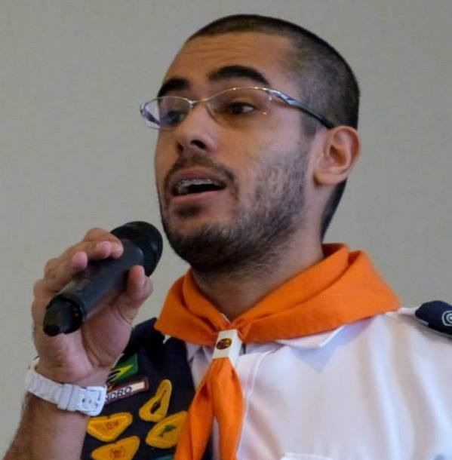

SKILLS
• Dedicated, enthusiastic and friendly Physical Education Teacher with 4 years of experience. I enjoy being children`s teacher/coach supporting and facilitating each child`s physical, intellectual and social growth by creating an atmosphere of mutual respect and cultural exchanger. Organized, making lesson plans that adds administration of knowledge in correct time and space to individual or groups. Encouraging, motivating students to physical fitness will be an enjoyable part of life.

EDUCATION
- Graduation in Physical Education - UNASP- São Paulo/Brazil (2011 - 2014)
- Scientific research group member at Adventist University of São Paulo (2013-2014)
- General English - Ned Training Centre - Upper Intermediate Level (Mar 2015 - Nov 2015)

WORK EXPERIENCE
• ELEVEN CAFE GOURMET AND P’MACS (DUBLIN/IRELAND) - Kitchen Porter, Kitchen Assistant and Waiter 08.2015-
I’ve been working as a Restaurant staff, placed in Dublin, washing, drying and storing dishes; cleaning the kitchen, helping the Chefs and covering waiters in many opportunities.
• FUNDAP AND PIBID (SÃO PAULO/BRAZIL) - Physical Education Teacher Trainee 02.2013-02.2015
I worked two years watching, helping and being physical education Teacher in thirteen classes (primary and secondary school), planning and applying lessons for standard and special classes.
• PREFEITURA DE SÃO PAULO (SÃO PAULO/BRAZIL) - Sports Coach 01.2012-06-2013
I worked one and a half year teaching tennis, volleyball and soccer/football for beginners in a partner club of public school (all ages).
• PATHFINDERS CLUB (SÃO PAULO/BRAZIL) - Volunteer Teacher 11.2010-11.2014
I worked four years teaching and coordinating recreation on weekends at the Pathfinders Club (department of the SDA Church, which works specifically with the cultural, social and physical education of children and adolescents).

