Curriculum Vitae

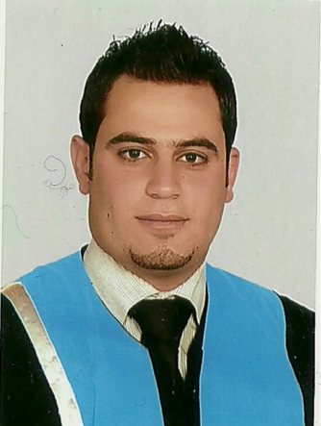
Personal Information:

Job title: Registered Nurse
Name: Ahmad
Ahmad.333245@2freemail.com
Place of birth: Jordan
Date of birth: Jan 30th, 1988
Nationality: Jordanian

Languages:

- Arabic: First Language spoken and written.
- English: Very Good spoken and written.

Objectives:

- Seeking new challenges in nursing which effectively utilizes Nursing experience.
- Looking to join a progressive organization that has the need for nurses and offers opportunities for advancement.
- To gain firsthand experience in Nursing, using my analytical skills and commitment to perform quality work.
- To obtain a position in a hospital by using my administrative and skills.
- To develop good critical thinking.

Education:

- Bachelor of Nursing, Jordan University of Science and Technology (JUST) , (72.3), Good, 2006-2010.
- General Secondary Certificate (Tawjihi), Science Stream (74.1), 2005-2006.

The Profession:
- Currently licensed as Registered Nurse per Health Authority of Abu Dhabi (HAAD) Nov,2016.
- Currently licensed as Registered Nurse per Jordan Nurses and Midwifery Council
(JNMC) since 2010.

Experience:

- Apr 3, 2012 to Dec 31, 2015 Royal Medical Services
Rehabilitation Center “ICU Burn Unit” Registered Nurse

- March , 2016 Up to Present Arab Medical Center
Emergency Department
Registered Nurse

The Training and Course:

- ACLS (AHA)
- ECG Interpretation Training Course
- BLS (AHA)
- Hemodialysis Training Course for 6 months
- Course OF COMPUTER SKILLS

Other Information:

- I have Valid HAAD Liecence and Data flow, Nov, 2016.
- I have Valid Qatar Prometric and Data flow.
- I have Jordanian Driving Liecence.
- I can work in a team or individually.
- I am eager to learn new things, and I am fast learning.
- I have great respect for rules and terms that might concern working.
- I am a hard worker, and I can work under pressure and deadlines.
- I get along very well with colleagues and other personnel.
- I can use Microsoft Office software & the Internet.

