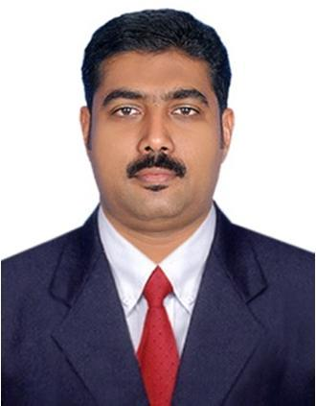
AYOOB
AYOOB.333254@2freemail.com

Career Objective

To add value to organization with the help of my adaptability and grasping power & to enhance my professional skill set in accordance with organizational objectives.
Experience

KRC FOOD INDUSTRIES LLC. , - Dubai September 2015 to till Date

Sales Supervisor

Oversees Execution of marketing plans

Create and execute campaigns & promotions

Identify marketing needs & highlight to other teams within marketing department Educate clients on existing programs
Meet monthly business target

Product launch, product growth tracking.

KRC FOOD INDUSTRIES LLC. , - Dubai April 2014 to Sep 2015

Key Account Executive

Discussing and implementing the promotions in Key Account Markets

Dealing with Carrefour outlet Managers for applying outlet wise promotions. Product Sampling with Promoter in Major Outlets

Managing the all Merchantiser and Sales executives. Improve interface between company & client

Dealing Key Groups:

- Carrefour Hyper Markets, Express Markets

- Union Co-Op Society

- RAK Co-Op Society

- Al Safeer Group

- Ansar Group

- Al Ashwaq Group ( Ras Al Khaimah )

FINEWAY INTERNATIONAL TRADING. LLC, Dubai Nov 2011 to March 2014

Sales Representative

Business / Account Development

Opening new Clients ( B & C class Markets ). Product launch, product growth tracking
Cross support for sales force

METRO FOODSTUFF TRADING Est., Abu Dhabi September 2005 to December 2010

Van Sales

Purchasing & supplying all kind of Rice, Oil, Pulses and Spices from various companies.

Total Deal Brands and Products in last 10 Years.

a. | Kaula Pulses, Spices, Rice , Oil
b. | Edimate Rice
c. | Falak Basmati Rice
d. | Malabar Taste Spices
e. | Milma Ghee
f. | Sunbul Basmati Rice
g. | Kwality Rice & Oil
Education
Secondary School Leaving Certificate
Pappinisseri Pancayath High School |  |  | March 1995
Pre-Degree Completed in Calicut University |  |  | June 1997
Deploma in Material Management
Govt. of India |  |  | March 2004
Software

Formation and Installation of all kind of Operating System ( Windows )

All Microsoft software knowledge: Word, Excel, Power Point, Outlook, etc… Editing the Image, Videos and Audio
Tally Accounting Software from 6.3 to ERP 9 series
Languages

English Hindi Arabic

Malayalam
Personal Details

 | Date of birth | : | 22nd November 1976
 | Nationality | : | Indian
 | Marital Status | : | Married
Declaration

I do hereby declare that the information mentioned above is true to the best of my knowledge & belief.

Place:Dubai
Date: 01-01-2017

