Shivaji  Visa Type: Visit Visa  Email : shivaji.333264@2freemail.com | 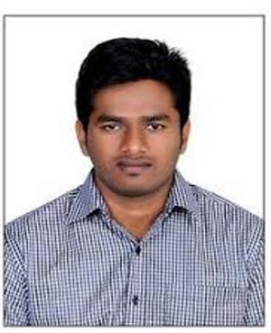

OBJECTIVE:

Looking for a challenging position in Healthcare Industry where my technical, logical & analytical skills will greatly enhance the growth and success of the organization. A position to learn incessantly, to contribute effectively, and to grow along with the organization.

WORK EXPERIENCE:

- Nearly 3 Years of Experience in Evaluation and Management and IP DRG coding as Senior Medical Coder in E4E Healthcare Business Services Pvt Ltd, Chennai.
- Perform Professional coding for medical centers located in the US healthcare network.
- Code medical records with ICD-10, CPT, and HCPCS Level II coding, claims daily while maintaining 98% accuracy and achieving productivity goals.
- Promoted as Auditor (Quality Analyst) and into auditing coder’s claims for errors and maintaining quality for the past 14 months.
- Attained Employee of the Mid year Award for performing efficient coding duties within deadlines for three projects continuously.

RESPONSIBILITIES AND SKILLS:

- Transforming verbal descriptions of Diseases, injuries, medical, surgical, and diagnostic procedures, into numerical designations (codes).
- In-depth knowledge of coding techniques and guidelines of medical coding.
- Good knowledge of medical terminology, physiology and pharmacology.
- Coding appropriate CPT & ICDs for the patient records based on the insurance according to client instructions provided & keeping compliance with HIPAA (Health Insurance Portability and Accountability Act).
- Proficient in computer (MS office tool, Database and pre-built medical software/applications).
- Excellent in communication, interpersonal and organizational skills.
- Expertise on ICD-9 to ICD-10 Transformation.

CERTIFICATIONS:

- AAPC approved Certified Outpatient Coder (COC).

- AAPC approved ICD10 Proficiency.

- AAPC approved Certified Inpatient Coder (CIC).

MEDICAL SOFTWARES / APPLICATIONS USED:

- Citrix Receiver
- Optum Encoder Pro
- 3M application

ACADEMIC PROFILE:

- St.Mary’s College of Pharmacy (B.Pharmacy) 2009-2013.
- Krishnaveni Junior College (Intermediate) 2007-2009.
- Loyola High School (SSC) 2006-07.

PERSONAL STRENGTHS:

- Strong initiative and self – motivation
- Good communications skills.
- Ability to develop and sustain working relationship.
- Punctuality, Dedication, Sincerity and Efficiency in work

PERSONAL PROFILE:

Date of Birth : 10th April 1992
Gender : Male
Marital Status : Single
Languages Known : English, Telugu, Tamil, Malayalam and Hindi.
Hobbies : Swimming, Reading books.

DECLARATION:

I hereby declare that the above mentioned information is true to the best of my knowledge. I will make it my earnest endeavor to discharge competently and carefully the duties you may be pleased to entrust with me.

Date:
Place: Dubai

