SANJEEV
SANJEEV.333296@2freemail.com

BUSINESS DEVELOPMENT AND SALES PROFESSIONAL

PROFILE IN A NUTSHELL
Highly-motivated and result-oriented sales professional with over 12 years of experience working with reputed multinational organizations both in the U.A.E and India.

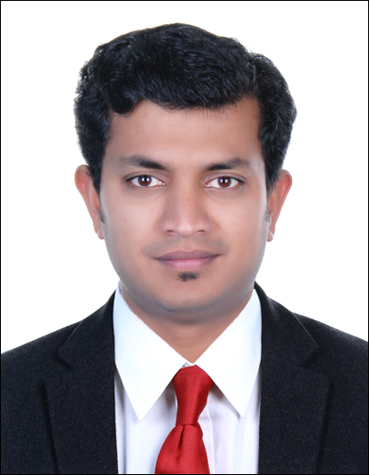

PERSONAL DETAILS

EMAIL

CORESKILLS
Organizational Planning Sales and Promotion Event Management Negotiation Skills
Staff Management Communication Skills Administrative Skills

IT SKILLS
MS Office
Adobe Applications Sage 50 Premium QuickBooks
Tally

NATIONALITY
Indian

LANGUAGES
English, Hindi, Malayalam and Tamil

VISASTATUS
Employment Visa

MARITAL STATUS
Married

OTHER
Driving License holder

REFERENCES
Available upon request

WHY HIRE ME?
      - Possess significant knowledge & experience in business development and sales.
      - Exceptional interpersonal, negotiation, team management and communication skills.
      - Passionate sales professional and expert in carrying out personalized sales strategies for the organization; possess relevant skill set in streamlining operations and enhancing productivity.

WORKING EXPERIENCE
KOSMONTE FOODS LLC,Dubai Dec 2014 –Present

KEY ACCOUNT EXECUTIVE
      - Meet potential customers to form new business pipeline; work on incremental opportunities while maintaining current business from existing clients.
      - Obtain orders from key markets such as Carrefour, Spinneys, Choithram, Geant, Sharjah Co-op and Lulu Hyper Market
      - Drive and maximize sales and profitability while ensuring outstanding service through client communication, product knowledge, and solution-based selling.
      - Apply stock management skills to log check, locate and move stock both in and out; check and carry out stock replenishment for display.
      - Strategize new sales including promotions and expanding into other areas; monitor payments for orders that are already delivered.

EMIRATES HOUSE GROUP LLCS, Abu Dhabi Apr 2012 – Sept2013

ACCOUNTANT
      - Performed variety of tasks that includes but were not limited to reconciling of petty cash, preparation of cash, bank and journal voucher, general ledger entries, and invoice generation.
      - Entered financial data and transactions into system.
      - Chased outstanding customer accounts, resolved invoice queries, and communicated clearly and effectively with the account steam.
      - Summarized available financial status by collecting information; preparing balance sheet,profit and loss statement, and other reports.

GSM COMMUNICATION SYSTEM PVT LTD,India Jan 2010 – Feb2012

BUSINESS DEVELOPMENT OFFICER
      - Promoted the company brand to key buyers, ensuring their knowledge is current and appropriate.
      - Generated new business through face-to-face meetings, over the phone, value-based sales proposals with both the clients and suppliers.
      - Developed, produced and delivered projects from proposal right up to delivery.
      - Implemented strategic marketing plans in order to attract more customers for a commercial establishment.
      - Provided leadership, motivation, direction and support to the team while attended industry events, engaged in business networking, and identified potential clients of partners.
      - Managed and executed projects while maintained budgets and meet organization's expectations.
      - Demonstrated technical marketing skills and product knowledge to the executives.

PKB ENTERPRISES,India Feb 2004 – Nov2007

SENIOR SALES EXECUTIVE
      - Sold products by establishing contact and developing relationships with prospects; recommending solutions.
      - Maintained relationships with clients by providing support, information, and guidance; researching and recommending new opportunities; recommending profit and service improvements.
      - Prepared reports by collecting, analyzing, and summarizing information.
      - Maintained quality service by establishing and enforcing organization standards.

EDUCATION AND CERTIFICATIONS

2009 MASTER OF BUSINESS ADMINISTRATION
European University (Switzerland), Singapore

2002 BACHELOR OF COMMERCE
Calicut University, India

