CURRICULUM VITAE

CAREER OBJECTIVE
Attaining personal and professional satisfaction through taking a challenging and creative role in the organization that would give me enough leeway to steer towards fulfilling company’s objective, while fostering team spirit, with a commitment to company excellence.

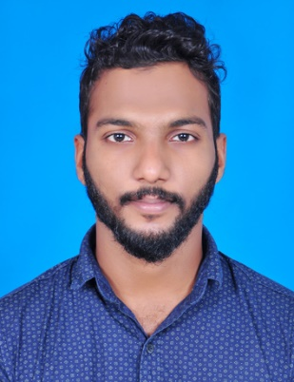  Strengths  - Inter personal and analytical skills  - Ability to work as a part of a team  - High adaptability  - Perseverance and Integrity to Work  - Optimistic  - High sense of commitment and dedication  - Ability to learn and adapt new technologies fast  - Excellent Presentation skills  - Good Communication Skills  - Work with deadlines ahead of time | PERSONALITY TRAITS  - Competent and dynamic professional  - Strong bottom-line orientation with proven records of accomplishments. Exceptional leader, change agent strong emphasis on organizational development leading to an empowered and highly motivated organization.  - Outstanding mentoring skills, increasing growth and confidence among team members.  - Achievement and result oriented with excellent communication, presentation & interpersonal skills.  - An adaptable, detail-oriented, strong learning and organizing skills matched with the ability to manage stress, time and people effectively.  - Ability to understand and analyze the work, and assist in planning strategies to achieve results.  Work profile  - Worked as an HR Assistant manager in CHEMMAYI SWEETS, Anjarakandy, Kerala, India for 1 year.  Duties and Responsibility  - Answering employee questions.  - Creating and distributing documents.  - Providing customer services to organization employees.  - Maintaining computer system by updating and entering data.  - Setting appointments and arranging meetings.  - Administrating new employment assessments.  - Ensuring background and reference checks are completed.  - Maintaining current HR files and databases.  - Planning, organizing and controlling organization activities.  - Assisting with employee relation.  - Assisting with the day-to-day efficient operation of the HR office.  Academia  Sl no: Qualification University/Board Passed out  1 MBA HR AND MARKETING BANGALURU UNIVERSITY 2016  2 BBA DR CV RAMAN UNIVERSITY 2014  3 Higher secondary State Board of Education, Kerala 2011  4 High school State Board of Education, Kerala 2009  Academic Projects  - CCUSTOMER PERCEPTION TOWARDS SHRADDHA ENTERORICES , KANNUR  - A STUDY ABOUT BITCOINS  IT Credentials  - OS:  - Windows 2000, XP, Windows 7 & 8  - Packages:  - Microsoft Office- word, Excel, power point, outlook  Achievements  - Lead from the front in organizing several formal and informal events at Graduation as well as Post Graduation Level.  - School cricket team (2009-2011).  - Participated in Off-Road races.  I hereby declare to bear the responsibility for the correctness of the information given in this resume.

