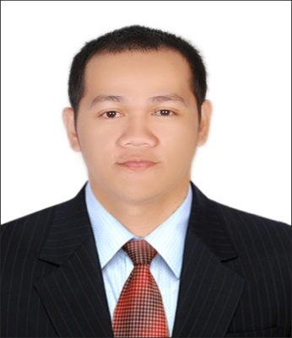
Ernesto
Ernesto.333308@2freemail.com

Professional Experiences:  La Meron Leather Trading LLC  Dubai, United Arab Emirates  (Sept 2015 up to present)  La Meron (Made in Italy)  High End Luxury Leather Stuff  The Mall Jumeirah  Dubai, United Arab Emirates  (Sept 2015 up to present)  Position: Sales Executive Shop In-charge  Duties and Responsibilities:  Managing the sales process for new prospects, from initial contact through to closure.  Dealing with customer inquiries face to face, over the phone or via email.  Contacting prospective customers and discussing their requirements.  Achieving all revenue targets & objectives.  Working closely with the marketing team to produce any sales collateral required for the target market.  Reporting business trends and area performance to the manager.  Developing & maintaining successful business relationships with all prospects.  Identifying what customers want.  Developing a full understanding of the business market-place.  Al Khaja Hospitality Group  Dubai, United Arab Emirates  (April 2011 – April 2015)  Alviero Martini 1st Classe (Clothing and Accessories)  WAFI Mall  Dubai, United Arab Emirates  (October 2013 – April 2015)  Paris Hilton (Accessories, Perfumes and Handbags)  Deira City Center, Reef Mall.  Dubai, United Arab Emirates  (January 2013 –October 2013)  SACOCHE (KENZO, Roberto Cavalli, Roccobarocco, Versace Jeans, Cerruti 1881, Valentino, Guy Laroche)  Battuta Mall, Deira City Center, Reef Mall, Hamarain Center, Dubai Festival City.  Dubai, United Arab Emirates  ( April 2011 – January 2013)  Position: Sales Associates Shop In-charge  Duties and Responsibilities:  Turning costumer service into sales. Anticipates, reacts responsibility to an exceed costumer’s requirements in a friendly and approachable style.  Follow correct procedures quickly and efficiently. Follows brand guidance and information on best sellers to maximize sales.  Using selling techniques to increase transaction value and overall store turnover.  Maintain a high end visual merchandising in fashion and footwear.  Develop and understand the international market, current trends, competition and merchandising concepts. |  | Career Objective:  To obtain a position in the management field where superb communication, skills and knowledge can help increase the company’s productivity and profitability. To further develop my abilities for continuous career improvement.  Profile:  Leading comprehensive strategies to support overall achievement of business qualities. To drive efficiency and productivity.  Skills:  Hard working, flexible and resourceful.  Computer literate (Word, Excel, PowerPoint). POS Machine, QuickBooks 2015  A proactive individual with a logical approach to challenges can be performed effectively within a highly pressured environment.  Able to handle multiple tasks.  Has an excellent written and oral communication skill.  Assertive high achiever always aiming for a higher performance.  Educational Qualifications:  TESDA ACCREDITED  MicroCADD Technologies Company, Inc  Bacoor., Cavite, Philippines  AutoCAD 2010 with Color Rendering  July 2010  Technological University of the Philippines  Dasmariñas City., Cavite, Philippines  Bachelor of Science in Architecture (Undergraduate)  SY 2003 – 2004  This is to certify that the above information is true and correct to the best of my ability.

