Lijo
Lijo.333324@2freemail.com

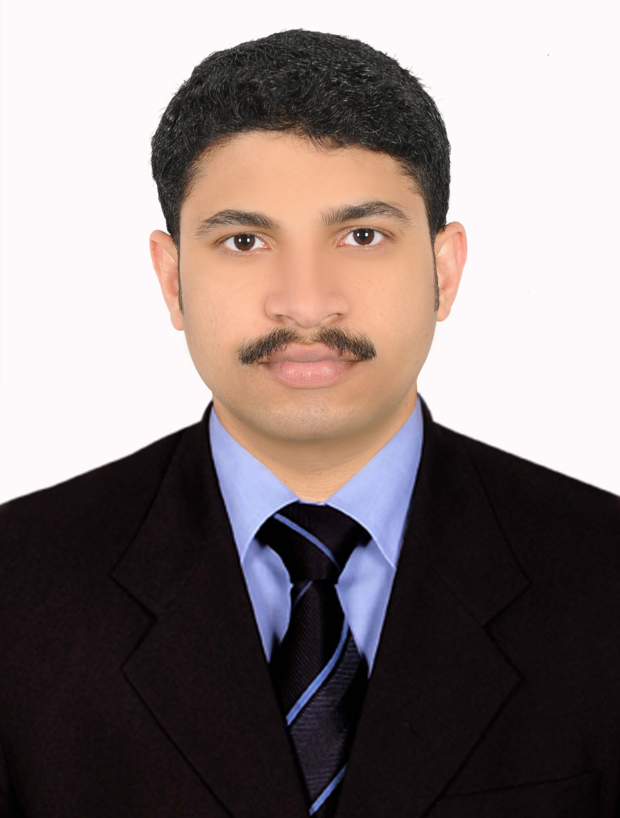

CAREER OBJECTIVE
Skilled and experienced Radiographer looking for a challenging role in the field of
Radiology.

SKILLS

Good communication and observation
Ability to answer questions and offer advice
Happy to work as part of a team
Dealing with emotionally charged situations

EXPERIENCE SUMMERY

More than 10 years’ experience in various Radiology department.

PROFESSIONAL BACKGROUND

- Working as a Radiography Technician in LLH HOSPITAL , Abudhabi Since 01/08/2015 to till date.

- Working as a Radiography Technician in AL AHALIA HOSPITAL, abudhabi Since 21/04/2013 to 17/04/2015

- Working as a X-Ray Technician in AL NABA MEDICAL DISPENSARY, Jubail, KSA. Since 03/03/2011 to 03/03/2013.

- Worked as CT scan Technician in WEST FORT HI-TECH HOSPITAL, Thrissur, Kerala, India. Since 08/11/2007 to 07/08/2010.

- Worked as a Radiography Technician in JUBILEE MISSION MEDICAL COLLEGE & RI, Thrissur, Kerala, India. Since 01/08/2006 to 31/07/2007.

PROFFESSIONAL QUALIFICATION:

COURSE | BOARD/UNIVERSITY | COLLEGE/  INSTITUTION | DURATION | % OF  MARKS
Diploma in Medical Radiation Technology (DMRT) | Christian Medical Association of India (CMAI) | Jubilee Mission Medical College & RI Thrissur | 2 Years | 64%
Vocational Higher Secondary Education (VHSE) | State Board Of Vocational Higher Secondary | Government Higher Secondary School Nandikkara | 2 Years | 61%
SSLC | Board Of Examination Kerala | Deepthi High School Thalore | 10 Years | 69%

JOB RESPONSIBILITIES

- Maintain highest possible standard of patient care at all times

- Responsible for maintaining Department inventories and stocks as per hospital policies

- Preparing and accompanying patients for special investigations, taking care of following infection control practices.
- Maintaining proper waste disposal according to the hospital policy.
- Giving psychological support to the conscious patient and orientation to time, place and person.
- Overall management of the Department

- Supervision of junior staff Student and other hospital aids during duty

EQUIPMENTS FAMILIAR WITH:

In all institution I had managed the following machines independently.

MRI : Philips Gyroscan Intera
CT-Scan Multi Slice : Philips Brillance 64 Channel CT-Scan Single Slice : Siemens Somatom Emotion
CT-Scan Single Slice : CT/e Wipro GE
CT-Scan Cinvenional : GE Sytec 2000i Whole Body CT

Digital Radiography
Fuji DR : 1000mA

Computerized Radiography
Fuji CR CAPSULA XLR : 800mA

BMD : GE LUNAR PRODIGY

Conventional Radiography

Elpro GE MST 1025 : 1000mA
Siemens Multix Basis : 800mA with floating Table Bucky
Siemens Klinoscop H : 500mA
Siemens ploephos D : 300mA
Ortho Pantomography : Villa Sisterni Medical Rotography Plus
Dental Unit : Villa Sisterni Medical EXPLOR-X70
Mammography : MDM HF

Mobile Units
Siemens Multi Mobile2.5 : 60mA
Siemens Ploedore 3 E : 60mA
Siemens Rontgenkugel : 12mA

I have got ample knowledge in special procedure such as CT Contrast studies, Ct guided FNAC, CT Angiography, CT Perfusion studies, CT Virtual Endoscopies, IVU, Cystography, MCU, RUG, Myelography, Cholangiography, ERCP, Sinogram, HSG, Mammography, OPG Dental Radiography and All Barium studies.

PROFESSIONAL MEMBERSHIP
Organization Membership Status Reg No.
- Kerala Board of Education Life
- Kerala Board of Vocational
Higher Secondary Education Life Long
- Christian Medical Association
Of India Life Long
- Indian Association of Radiological
Technologist Life Long
- Saudi Commission for Health
Specialist (Saudi MOH License ) 3 Year
- HAAD 2 Year

PERSONAL PROFILE
Date of Birth : 29-01-1987
Sex : Male
Religion : Christian
Nationality : Indian
Marital Status : Married
Languages Known : English, Arabic, Malayalam & Hindi
Place of issue : Cochin
Date of expiry : 24-07-2017

Declaration
I hereby declare that all the information’s given in these curriculum vitae are true, accurate and a fair reflection of my ability.

Date :
Place : Abudhabi

