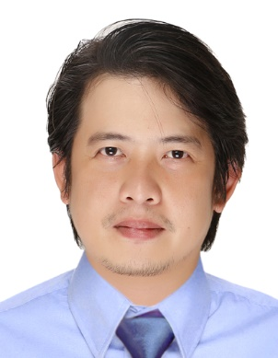
OMAR
OMAR.333333@2freemail.com

CAREER OBJECTIVE

To obtain any position that would best fit my qualifications and develop further my talents and skills for continuous career improvement.

SUMMARY OF QUALIFICATIONS

- Graduate of Bachelor of Science in Nursing
- Attained numerous hours in nursing experiences
- 42 units of RLE with the total hours of 2268; completed 5 cases of Major scrubs, 5 cases of minor scrubs, 5 cases of delivery handled, 5 cases delivery assisted and 5 cases of Cord Dressing total of 25 cases that is required by a nursing course
- Good communication skills
- Hardworking, flexible, quick learner, patient, teamplayer

PROFESSIONAL EXPERIENCE
CONSULTANT, PROMESSERV CORPORATION, Philippines (October 2015 ~ October 2016)
- Rendered the Scope of Services to the Company or the Company’s subsidiary or related companies or its client; key roles are as follows:
- Processing Certificate of Product Registration for PROMESSO products in Food and Drugs Administration
- Processing of Tariff Classification, for PROMESSO products in Tariff Commission
- Processing License To Operate and Additional Source for PROMESSO in Food and Drugs Administration
- Consultant has offered to the Company the necessary knowledge, experience, competence and sufficient resources to undertake the services, and the Company accepted the offer subject to certain terms and condition

STRATEGIC BUSINESS SUPPORT SERVICES,
PROMESSERV CORPORATION, Philippines (June 2014 ~ October 2015)
- The position is responsible in providing effective and efficient business support services to all the business needs of the clients of PROMESSERV Corporation such as but not limited to their government compliances, customer services, supply (except office supplies) outsourcing, management of events and other business development –related services.

REGULATORY & BUSINESS DEVELOPMENT SPECIALIST– BIO+
PROMESSERV CORPORATION, Philippines (November 2013 ~June 2014)
- The position is responsible for the effective and efficient business development of BIO+, the consumer business of PROMESSO Business Solutions, Inc.

MANAGER (OFFICER-IN-CHARGE),
KAY GALING CORPORATION (Generika Drugstore) Philippines (March 2010- October 2013)
- In-charge in selling, counseling of patient, doing outside promotional activities and other tasks that may be assigned by the Franchisee.

Academic  Preparation | Collegiate
 | University of Perpetual Help System-DALTA
 | Pamplona, Las Pinas City, Philippines
Bachelor of Science in Nursing
Batch 2007
CHED Memorandum Order No. 27
Associate in Health Science Education (AHSE)
Completed

Trainings  & Volunteer works | - Basic Life Support (PNRC- Las PinasCity, Chapter) 18 Credit Hours  - Standard First Aid Training (PNRC- Las PinasCity Chapter) 36 Credit Hours  - Medical Mission as volunteer :  - Far Eastern and American Nurses Association of The Great Lakes, Medical/Surgical/Dental mission in coordination with City Government of Dagupan and Medical Centrum  Dagupan City and Malasique Pangasinan, Philippines  - Couples For Christ Medical and Dental mission  St. Joseph Academy Quadrangle, Las Pinas City, Philippines
Personal
Profile Date of birth : October 31, 1981
Marital Status : Married
Visa Status : Tourist
Character Reference | Available upon request

