RESUME FOR THE POST OF INSTRUMENT TECHNICIAN

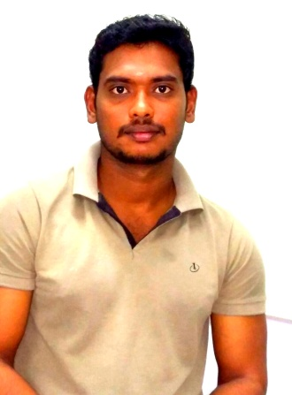
SHANKAR
SHANKAR.333373@2freemail.com

OBJECTIVE
To excel in technical fields, the inspiration to be a continuous learner and
Perseverance to overcome challenges in life and career and to serve the
Society.
EDUCATIONAL QUALIFICATION
Class Obtained | Course | Institution | Year of Passing | % of Passing
First | DIPLOMA IN ECE | PSN Institution of Technology , Mela Thediyoor,  Tirunelveli | 2010 | 82%
First | H.SC | Dr. Ambedkar Hr. Sec.School, Tirunelveli | 2008 | 71%
First | S.S.L.C | Anupparpalayam Hr. Sec.School , Coimbatore | 2006 | 70%
PROJECT WORK

Title : Automatic Temperature Controlled Fan using Microcontroller.

Team : 6 members

PERSONAL PROFILE

Date of Birth :04-07-1990
Age :26 Years
Sex :Male
Marital Status :Single
Languages Known :Hindi, Tamil& English

Experience Details: TOTAL 6 YEARS 5MONTHS

PREVIOUS
- Working with DCW Chemicals (oil&gas), Tuticorin, Tamilnadu
Designation : Instrument Technician
Duration :04.07.2010 to 15.3.2014

PRESENT
- Working with Kharafi National, Abu Dhabi
Designation : Instrument Technician
Duration : 06.05.2014 to 30.12.2016 (present)

Instrument Handled:
- Loop checks and commissioning of all field smart instruments.
- Then all Electronics PCB Boards circuits components checking, problem finding & rectify that problem within short time.
- I had worked with different types of SMART Transmitter like(rose Amount, Honeywell, yokogawa, mass flow meters, and vortex flow meters) and Positioners for measurements and control of flow, pressure, temperature and level.
- I have experience in serviced and calibration of all types of pneumatic control valves and on/off valves (like ball valve, butterfly valve, gate valve, globe valve, etc.)
- Interpretation of loop drawing, instrument cabling and terminations, cable schedule, hook-up drawing, and PID drawings.
- I have experience in handle gas analyzer and detectors instruments like H2S, O2, CO2, Methane etc.
- I have experience in handling communicators like HART 375 Rosemount.
- I had worked with Analytical meter like PH, CONDUCTIVITY, ORP, AMMONIA and DO. Also I done calibration in field using buffer solution ph4, ph7, ph10 and membrane.
- I have familiar with the latest process control technology like DCS, Yokogawa centum cs 3000 and SCADA GE FONAC.
THANKING YOU
I hereby declare that the details furnished above are true to the best of my knowledge and belief.

