HAAD-RN PASSED – 4 YEAR EXPERIENCED IN EMERGENCY WITH AMBULANCE SEVICE, ACLS & BLS(AHA)

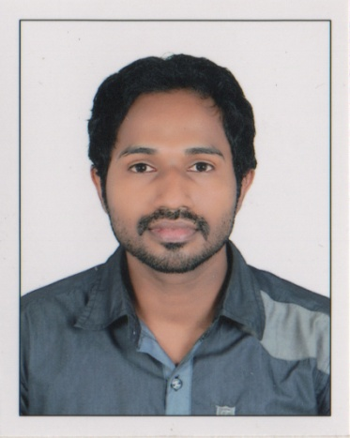

Name : SHAFEE

E-mail Id: SHAFEE.333416@2freemail.com

Personal Details:
Date of Birth : 25-05-1988
Age / Sex : 27 Years / Male
Marital Status : Single
Religion : Islam/Muslim
Nationality : Indian
HAAD Details:
Passport Details:

Issue Date : 14/02/2012
Expiry Date : 13/02/2022
Area of working:
Institution | Bed Capacity | Position | Department | Period
KIM’S AL SHIFA Hospital;  Perinthalmanna,Malappuram | 500 Bedded  NABH  Hospital | STAFF  NURSE  (Team leader) | Department of Emergency Medicine | 08-10-2012 TO  20-10-2016

Duties and responsibilities:
- Receiving the patient.
- Provide emergency care and total comprehensive care for the patient.
- Total care for the patient.
- Performing special procedures like catheterization, Ryle’s tube insertion.
- Assisting in special procedures like intubation, suturing.
- Diet planning for the patient.
- Communication.
- Implementing the orders by the physician.
- Recording and reporting.
- Attending in staff educational programmes.

Professional Experience:

- Worked as a staff nurse in KIMS ALSHIFA Hospital Perinthalmanna
- Tertiary level Super speciality referral hospital
- NABH accredited , ISO 9001-2008 certified hospital
- 500 bedded hospital
- Total experience is 4 years.

Software Proficiency:

- Operating systems:- Windows 98/2000/XP/VISTA/ 7/8
- MS OFFICE,Yasasi operating system

Strengths:

- Good communication skills.
- Accustom to any climate.
- Willingness to learn
- Flexible

ACADEMIC QUALIFICATION

Qualification | Institution | Year | % of Marks
CBSE 10th | Sree Buddha Central School | March 2003 | 70.6%
CBSE 12th | Sree Buddha Central School | March 2005 | 64.6%

PROFFESSIONAL QUALIFICATION

Qualification | Institution | Year | % of Marks
B. Sc Nursing | Al Shifa college of Nursing Perinthalmanna | 2007-2011 | 61%

NURSING REGISTRATION

Professional Registration | Kerala Nurses and Midwives Council

DECLARATION

I hereby declare that the above furnished information is true to the best of my knowledge.

