DARSHAN
DARSHAN.333419@2freemail.com
TEFL-certified Teacher
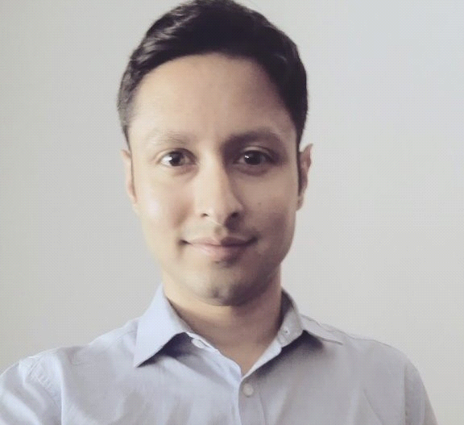
____________________________________________________________________________

PERSONAL DETAILS
Nationality: Republic of South Africa (Native English Speaker)
Date of Birth: 07/04/1986 (April 7, 1986)
Marital Status: Single

PROFILE
I hold an Honours Bachelor of Arts Degree from the University of South Africa. I have experience in the teaching field from my time as an English Teacher at a high school in South Korea. I also have experience within the corporate field after spending five years working at a financial services company in South Africa.

EDUCATION
Hello Academies TEFL, Prague, Czech Republic Nov/Dec 2016
- Completed an intensive 120-hour-in-person TEFL certification program;
- This course is externally accredited by the International Accreditation of TESOL Qualifying Organisations (www.IATQuO.org);
- I achieved eight hours of teaching practice which was observed by qualified trainers;
- The classes compromised of Czech students that were pre-intermediate, intermediate and upper intermediate English learners;
- I gained one to one teaching experience when I had undertaken a learner profile project which involved the analysis of a Czech student's reading, writing, speaking and listening skills;
- We were introduced to phonology to assist us with helping students with improving their pronunciation;
- Reviewed the criteria for English proficiency exams and how best to assist students to undertake them.

University of South Africa, Honours Bachelor of Arts (Post-graduate), 2009 - 2011
- Majored in Criminology;
- Degree completed in Durban, South Africa.
University of KwaZulu-Natal, Bachelor of Social Science (Undergraduate), 2005 - 2008
- Majored in Psychology & Criminology;
- Degree completed in Durban, South Africa.

WORK EXPERIENCE
GEPIK (Gyeonggi English Program in Korea) Full Time
ESL Teacher in Jeomdong-myeon, South Korea March 2010 - Feb 2011
Official Role: Taught conversational English to High School Students (aged 14 – 17) as part of a one year contract.
Responsibilities:
- Planning lessons;
- Participating in extracurricular activities;
- Chaperoning field trips and proctoring exams;
- Classroom learning aids such as smart screens, PowerPoint presentations and online sources were an integral parts of most lessons.

Bayport Financial Services Full Time
Forensic Investigator in Johannesburg, South Africa Mar 2011 – Aug 2016
Official Role: My position primarily revolved around the investigation of criminal offences, staff and loan fraud and other whistleblower cases received through the fraud reporting channels of the company.
Responsibilities:
- Required to lead team projects and high profile cases.
- Dealt with fraud complaints which needed me to liaise with customers on a regularly basis. This required me to be calm and collected in order to ease the concerns of the customer.
- I was in an advisory roles at times as sales staff would require assistance in dealing with fraud matters.
- Required to perform under pressure in order to constantly meeting deadlines and achieve KPI targets.
- Represented the company in disciplinary hearings against staff members found to have transgressed company policies.
- Maintained a professional conduct throughout my tenure.

ADDITIONAL SKILLS
- Implementing the use of whiteboards in classrooms to deliver effective lessons;
- Able to operate projectors where lessons required video and audio presentations.

IT SKILLS
- Proficient in Microsoft Office (Word, Excel, Powerpoint & Outlook);
- Proficient in Windows OS (through to Windows 8).

LANGUAGES
- Native English;

REFERENCES
Available on request

