CURRICULUM VITAE

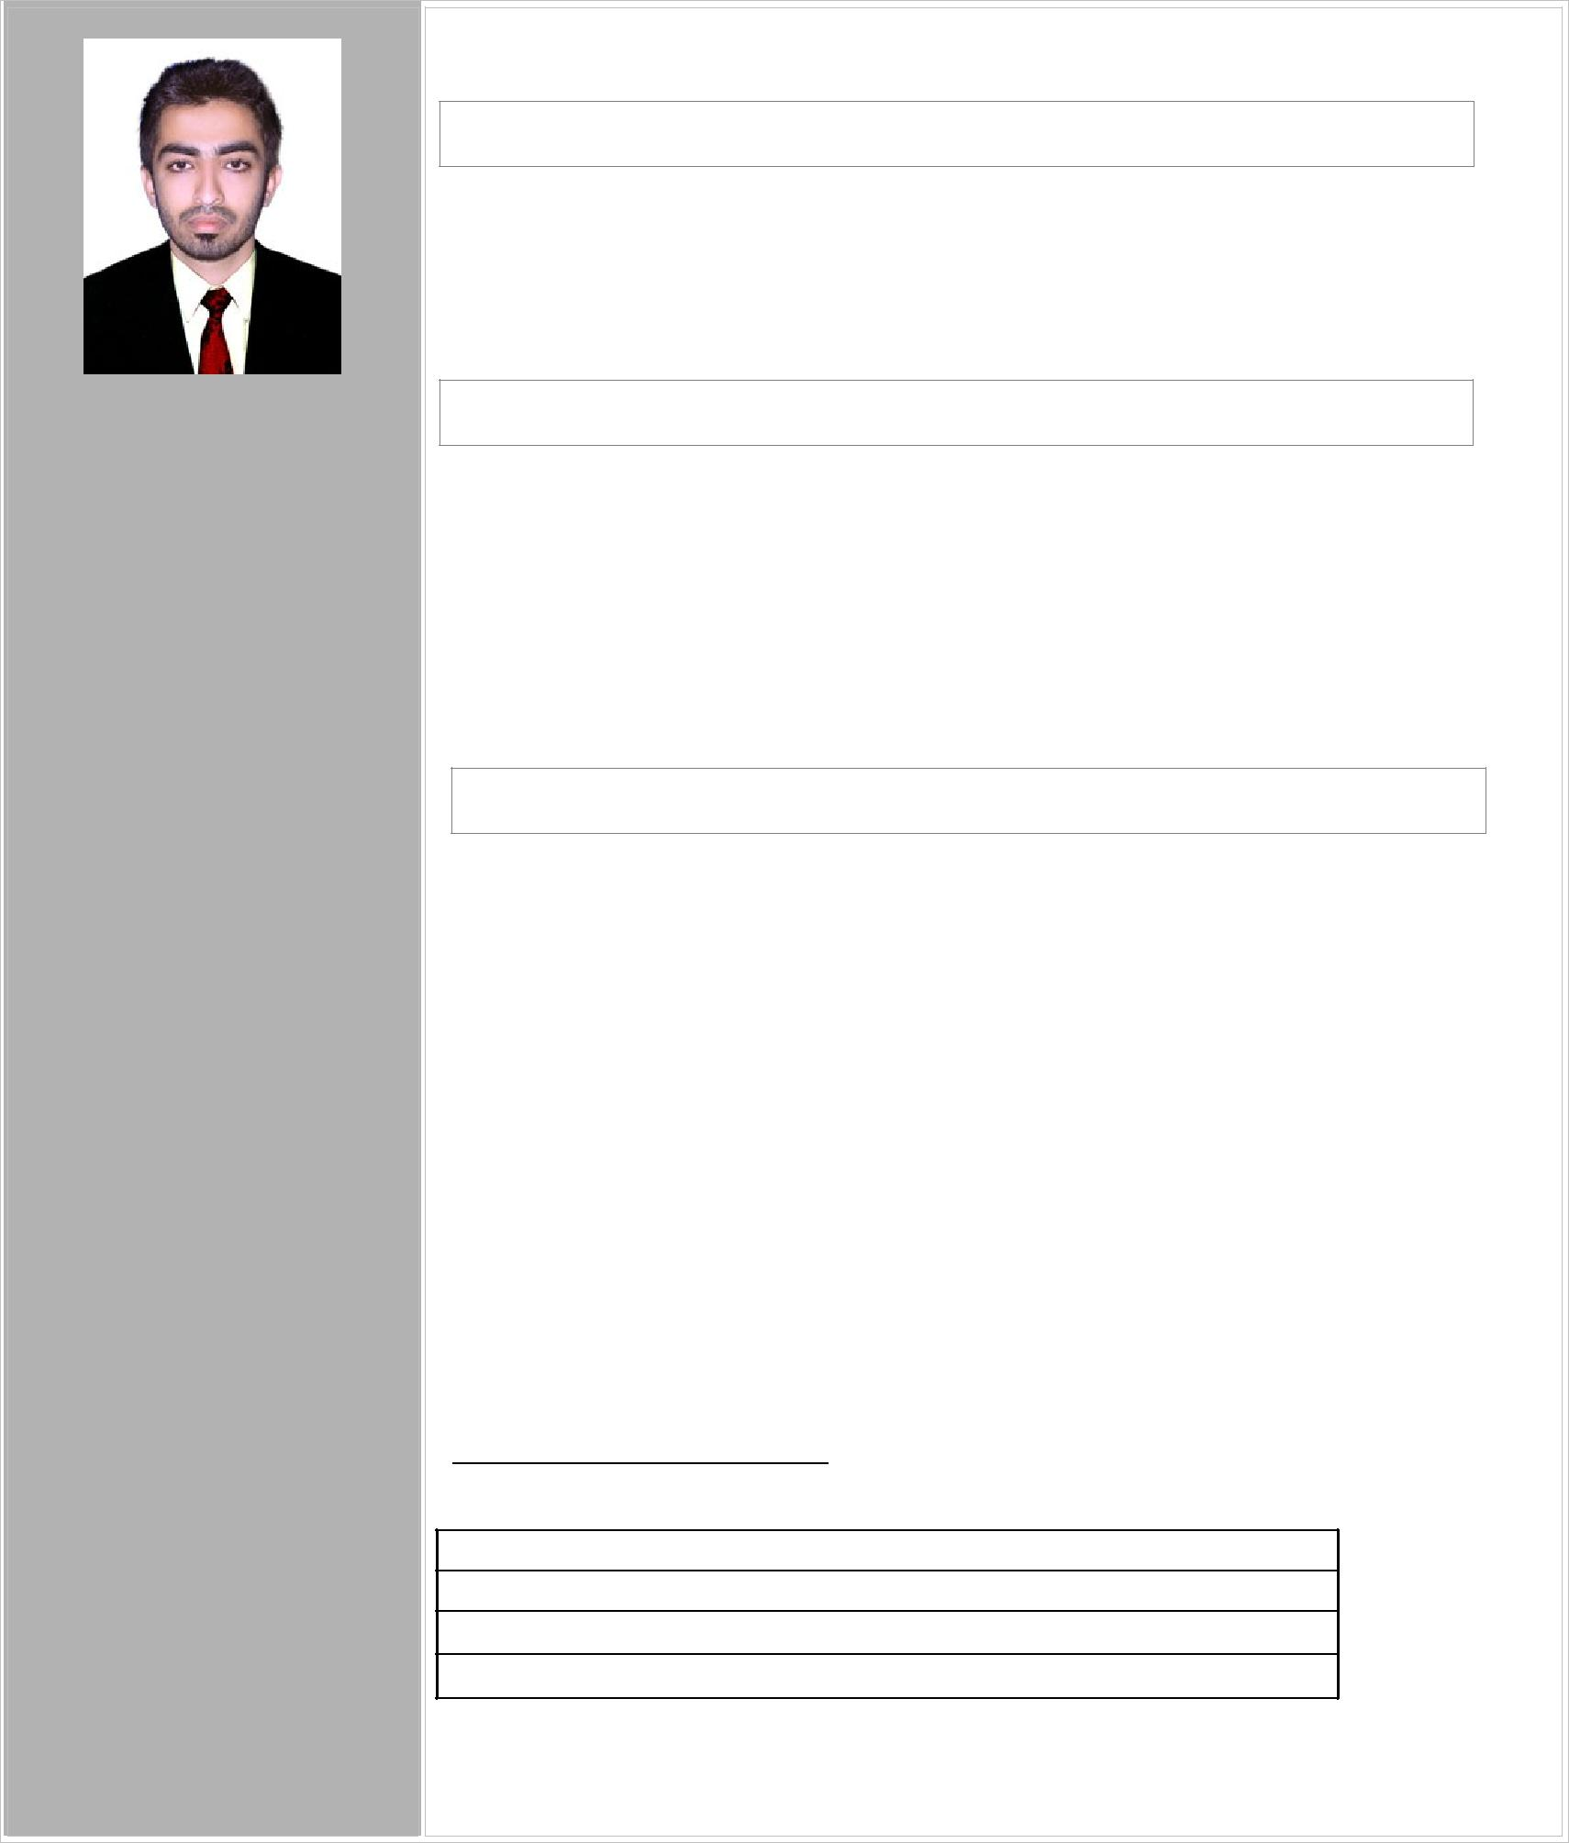

Mohammed
Mohammed.333421@2freemail.com

Abu dhabi
UAE

Personal Details:

D.O.B:01/01/1992
Gender:male

Nationality:Indian Marital status:Single

Visa Status: Emploment

Visa

Career Objectives

To attain a challenging and responsible position in software product applications development, for Developing / maintaining technical software applications that further enhance my skills and allow for Advancement.

Academic Profile

B-Tech course completed with 67% in Computer science and Engineering from MEA Engineering College (MEA), Perinthalmanna, Malappuram. (Affiliated to University of Calicut)
Completed Higher Secondary With 81% From kerala state Board. Completed SSLC With 80% from Kerala state Board.

Experience

Two Year Experience As IT Engineer.

  - RAMEZ Intl. Trading LLC Sharjah,UAE

One year of total working Experience in Microsoft Technology

    - Appstribes Technologies

23/718 ,Mini Bypass

Meenchandha

Calicut -673018

Duration : August 2013 – October 2014

Competency : C#.Net,Asp.Net, Java Script,Ajax,SQL Server

PROFESSIONAL CERTIFICATION

Microsoft Certified Solutions Expert (MCSE)

Microsoft Certified Systems Engineer(MCSE)

Cisco Certified Network Administrator( CCNA)

Computer Hardware Engineering Certification

I am Proficient in…

English

Malayalam Hindi

I am a…

- Played the role System Admin &Database Admin of A company

- Well experienced in Microsoft Server 2008,2012 R2 , Sql Server (2008,2012 &2014) And Networking

-Ability To troubleshoot all software and hardware problems of Client.

-Innovative, creative and helpful.

-Performs better when motivated.

-Ability to grasp the new skills very fast.

-Sincere & hardworking.

- Good analytical, technical and programming skills

- Experience in handling multiple systems simultaneously.

- Takes responsibility and always ready to work hard and take stress in crucial stages of project & meet deadline.

Technical Skills

✓Day to day troubleshooting IT issues - LAN, WAN, Desktop, Printers, PDA, Wi-fi

✓ Experience in Windows Server 2008, Server 2012 R2 and Win7, Win8, Win10 ✓Experience in ITSM (IT Service Management ) process

✓Troubleshooting via phone, email, or remote desktop connection

✓Manage Active Directory and ADC.  ✓Implement Active directory Group Policy
✓Experience in Server troubleshooting ✓Experience in POS systems. ✓Experience in Outlook
✓Experienced in new network implementation. ✓Sonic wall configuration and managing experience .
- I T Asset inventory management

- Experience in Firewall

✓Configuring &troubleshooting LAN and Wireless issues

✓TCP/IP Network Problem resolution and Wireless Network Configuration

- Installation and configuration in Various business applications

- Outlook confirmation experiences

✓Well Experienced in structured cabling system

✓Handling experiences PDA Devices
✓Troubleshooting and managing WAN connections (MPLS, VPN) ✓ Experience in Managing Alcatel-Lucent SLI 4-2 IP phone Server
✓Experiences in NAS (Network attached storages ) - WD My cloud EX4

✓Install, configure and troubleshooting Desktop including peripherals, hand held, Multi functional Devices (MFD's), Local Printers, Network printers, Barcode printers and Barcode scanners, Document Scanners

 ✓Managing and monitoring project filed engineers.

✓Troubleshoot and resolve Desktop software, business applications, system, peripheral and handheld mobile device issues.

- Positive thinking

- Smart worker

- Team player

- Quick learner

- Promoted to any environment

- Good creativity

- Communication skill

✓SQL Severs 2014, 2008 r2replication monitoring and management .

✓SQL Server 2014,2008 r2Database Backup, Different locations through remote.

✓ Experience in Acronis True Image 19.0 Backup

✓Experienced in voice logger server support ✓Experienced in Server Raid Configuration
✓DELL Power Edge R630, R220 Series Servers and HP V1910 Series manageable Switch's
✓Close coordination/assistance to Network Management Department(NM1)for any onsite node down issues, including basic troubleshooting ,resetting routers/switches ,etc
✓McAfee, Norton Antivirus Support expert Windows XP/Vista/Win7/Win8/Win10

✓McAfee HDLP configuration

✓Experience in configuring outlook, office applications  ✓End User Support Project management, Vendor Coordination
 ✓Project activities, as required (e.g. Win7 Upgrade project, Asset Management).  ✓Install, uninstall and configure software including client business applications
✓Client ERP based software's troubleshooting and Managing user Creation ✓Timely and accurate documentation of work performed, ticket updates and
time reporting.

✓Project coordination. (Vendors and Wipro-Partners ) ✓Configuring &troubleshooting LAN and Wireless issues ✓Knowledge server roles like DHCP,DNS,RAS
✓Handle IMAC’s (pre-approved, low impact– Install, Move ,Add and Change)

 ✓Maintained company servers, computers, printers, cables and other equipment.

✓Responsible forth e support of network services relating to desktop connectivity.

✓Working knowledge on NSE Neat and BSE applications

Declaration

I hereby declare that all the information given above is true to the best of my knowledge and bear responsibility for the correction of above-mentioned particulars.

Mohammed Haris k

