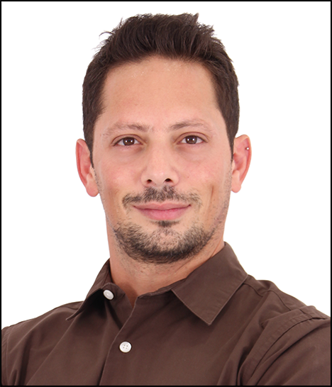
TAREK
TAREK.333422@2freemail.com

PERSONAL DETAILS
Date of Birth: July 18, 1976
Nationality: Spanish
Gender: Male

PROFESSIONAL EXPERIENCE

Nov. 2016 – present Humanagement – Dubai, UAE
Client Service Executive

Responsibilities:

- Build and maintain a strong relationship with the client
- Respond promptly to client inquiries, and handle and resolve complaints and requests
- Maintain fluid and clear communication between the client and the agency
- Communicate and coordinate with internal departments
- Ensure that projects are delivered on time and within budget
- Monitor and oversee the progress of projects between agency departments so that resources are directed to meet and exceed client expectations

May 2008 – July 2016 Spanish Embassy in Damascus, Syria
Administrative Assistant

Responsibilities:

- Conducting market research for Spanish Commercial Office
- Following up on regional news and events and preparing daily reports for the diplomatic corps
- Inventory and correspondence keeping
- Archiving and data management
- Ensuring proper functionality and availability of equipment and supplies
- Assisting with logistics and procurement of equipment
- Covering and giving assistance to a wide range of positions in the consular section
- Providing interpreting and translation services
- Giving assistance to the Cultural Section when organizing events

Aug. 2006 - April 2008 ALTEX Trading & Export - Damascus, Syria
Assistant Manager

Responsibilities:

- Management of company files and accounts
- Correspondence keeping
- Coordinatinating and organizing the schedule of international visitors and clients
- Served as liaison between the MD and the company’s associates and clients
- Representing the company in meetings
- Acting as translator and interpreter

1997 - 1999 Freelance Interpreter & Translator
Arabic, English & Spanish

- Provided translation and interpretation services for companies and private parties

ACADEMIC QUALIFICATIONS

2001-2005 Damascus University
B.A in English Literature

1995-1997 Lebanese American University
Minor in Business Administration

1990-1994 Pakistan International School of Damascus
International General Certificate of Secondary Education (IGCSE)

CERTIFICATES

- Certificate in Social Media Marketing – ALISON

LANGUAGES

- Spanish & English: Equally fluent in both languages (native level)
- Arabic: Native speaker

RELEVANT SKILLS

Computer/IT Competence

- Proficient with MS Office & Adobe Photoshop
- Perfectly acquainted with Internet browsers and related applications
- Research and data collection
- Excellent understanding of computer hardware, maintenance and assembly

Other skills

- Arabic calligrapher
- Graphic designer
- Web designer
- Editing

Personal Profile

- Great flexibility and adaptability
- Capable of performing tasks requiring autonomy and creativity
- High level of professionalism and commitment with a strong work ethic
- Proven administrative and organizational skills
- Good analytical skills

