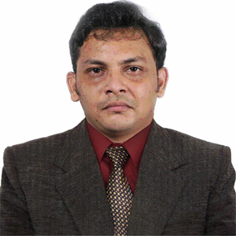
FAZIL
Fazil.333423@2freemail.com

To build a career in the field of ENGINEERING & DRAWING, and to work efficiently and effectively in a firm, so as to utilize and apply my knowledge, skills which would enable me to grow while fulfilling organizational goals.
EDUCATION

YEAR OF PASSING
-------------

INSTITUTION
-------------------

2012

2011

2011

2011

2010

2006

2004
AutoCAD in civil from Institution of CIVIL ENGINEERS India

Technical DIPLOMA in civil engineering from NIET group of institution,Calicut,Kerala

SYSTEM ADMINISTRATION from Zoom Technologies,Hyderabad-India

NETWORK ADMINISTRATION from Zoom technologies,Hyderabad-India

Engineering Designing and Drafting SSM Govt. polytechnic,tirur,kerala-India

PLUS-TWO from IKTHSS MALAPPURAM,KERALA-INDIA

SSLC from PMSAMHS,MALAPPURAM,KERALA-INDIA

PROFESSIONAL EXPERIENCE

Working for a Govt contracting company as SITE ENGINEER cum DRAFTSMAN

- Drawing Survey Data Roads as per Requirement in Auto Cad.
- Visiting sites and factory to help supervisors to monitor the progress.

OTHER EXPERIENCE

- Worked as an Executive in help desk of a leading mobile network company MAGUS CUSTOMER DIALOG-india.
- Sales and service Distributor of a telecom company UNINOR pvt.ltd.for two year

SKILLS

COMPUTER SKILLS:
- Windows XP,7,8,10 and Linux (OS).
- Basic knowledge in Computer Hardware&Software.
- Microsoft Office word.
- Microsoft Office Excel.
- Computer Administration.
- Network Administration.
- AutoCAD.
- Photoshop.
- All Other ordinary computer software.
OTHER SKILLS:
- Driving
- Basic knowledge in Electrical,Electronics&Mechanical
- Experienced in Retail business field.
- Knowledge in Desktop and Laptops hardware& software.
PERSONAL PROFILE

Gender : Male
Date of Birth : 31.03.1989
Languages Known : English , Malayalam , Tamil
Hobbies : Music,Reading , Playing Badminton.
DECLARATION:
I hereby declare that the above particulars furnished by me are true to the best of my knowledge and belief

