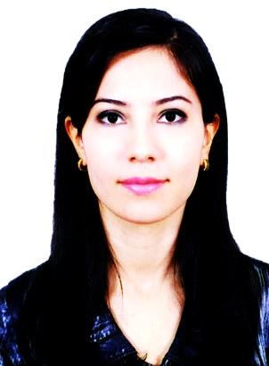
Manzura
Date of birth: 28.05.1987.
Marital status: married.
Nationality: Uzbekistan.
Visa status: Tourist visa valid till February 3, 2017.
E-mail: Manzura.333449@2freemail.com

Objective:
Career minded Foreign Language Teacher with many years of experience and the ability to work independently or as a team is seeking position.
Summary of Qualifications:
- Proficient in teaching within a challenging educational environment.
- Deep knowledge of various instructional challenges and projects.
- Remarkable ability in handling and working collaboratively with a variety of people.
- Excellent in oral and written communication skills.
Education: Bachelor`s Degree in Foreign Languages
Samarkand State Institute of Foreign Languages. English philology department. 2004-2008.
Work experience:
Foreign Language Teacher, January 2014 - October 2016, Samarkand Economy College.
- Incorporated selected best practices in lesson design and instructional strategies.
- Supported and participated in student events and activities before and after school.
- Implement the curriculum through unit and daily lesson plans and learning tasks.
- Maintained a learning-focused, safe environment in the classroom.
- Managed to incorporate community resources into learning experiences.
English teacher, September 2008 - December 2013, Samarkand public school, Uzbekistan.
  - Supported and participated in student events and activities before and after school.
  - Implement the curriculum through unit and daily lesson plans and learning tasks.
  - Managed to incorporate community resources into learning experiences.
  - Organized cooperative learning activities.
  - Tutored students after school and chaperoned field trips.
Personal qualities:
Responsible, initiative, determined, communicative.
Fluent in several languages: English, Russian, Turkish.
Hobbies: reading, travelling, sport.
Advanced level skills in Microsoft Office, computer skills, Internet Research.

References available upon request.

