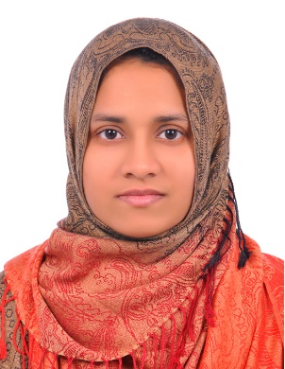
Nourah
Nourah.333514@2freemail.com

Objective

Seeking the position of a Science teacher in an organization that will give me an opportunity to utilize my skill set for the progressive movement of the organizational objectives with a focused vertical growth in my professional career as well.

Career Glimpse

- Currently working as Science teacher with Sabari Indian School, Dubai.
- More than two years’ experience as primary teacher in teaching field.

Also gained three years’ experience in reservation and ticketing in travel trade. Started my career as a junior travel counselor, with the focused and concerted efforts, I have been able to secure a responsible position in a considerably short span of time. During these years I gathered remarkable experience in handling customer queries, reservation and ticketing.

Professional Chronicle

Science Teacher in Primary Section (Sep2015-till date)
Sabari Indian School- Deira Dubai, UAE.

Science Teacher in Primary Section (May 2014- Mar 2015)
Bishop Pereira Memorial School-Kerala, India.

Ticketing Clerk (Oct 2007-Aug 2009)
Indian Airlines (GSA – Arabian Travel Agency)
Sharjah, UAE.

Jr. Travel Counselor (Feb 2006-Mar 2007)
PL Worldways Ltd
Kerala, India.

Skill List

Teaching
- Preparing creative teaching lesson plans.
- Ensuring classroom organization and pupil discipline.
- Using the latest technology to support teaching.
- Developing age and ability appropriate worksheets for lessons.
- Maintaining records.

Personal
- Able to teach students from culturally diverse backgrounds.
- Can quickly establish a rapport with parents, students and colleagues.

Technical Skills
- Operational Skills in Multiple Windows Office solutions

Educational Accomplishments

- Bachelor of Education (University of Kerala)-November 2013 with 89% marks.
- Bachelor of Science (University of Kerala) –April 2005 with 87% marks.
- Diploma in IATA/UFTAA Foundation and EBT Course-September 2005.

Personal Details

Date of Birth : 08.03.1984
Sex : Female
Marital Status : Married
Visa Status : Husband’s Visa (Valid up to September 2017)
Languages Known : English, Malayalam and Hindi.

