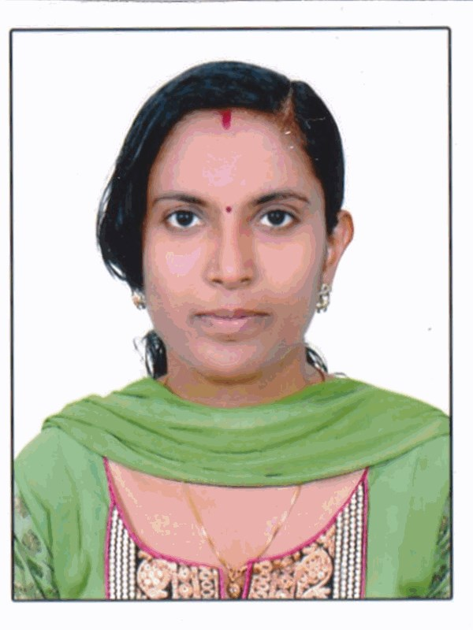
Navya

Email: Navya.333520@2freemail.com

Profession
Pharmacy Technician-DPharm (Registered Pharmacist-Kerala ,India )

DHA Eligibility

Career objective

Looking for an opening with a reputed organization, where I can start and develop my career and grow along with the organization

Work Experience

Worked as pharmacist in co-operative hospital in 2008-2009

Worked as pharmacist in ASA Company (from 13/01/2011 to 10/01/2015)

Worked as pharmacist in Sharanya medicals (from 02/03/2015 to 30/11/2015)

- Worked as pharmacist in Kolassery medicals (from 22/02/2016 to 29/10/2016)

Professional Experience

I have specialized skill in the following areas of pharmacy field:

Managed order entry and prescription verification

Identity of drugs

Maintaining of records for restricted drugs

Pharmacy related accounting

Dispensing of drugs

Attending Customers

Having good and friendly relationship with customers and homely relationship with colleagues

Professional Qualification

CLASS/COURSE | Board/University | Year of passing | Mark in Percentage
D.PHARM  (Diploma in Pharmacy) | Govt.of Kerala  Directorate of Medical  Education | April-2008 | 60.9%
Sanitary Inspector |  | May-2005 | 66.1%
Higher Secondary Education-12th | Kerala State Board | March- 2004 | 56.8%
Secondary Education-10th | Kerala State Board | March -2002 | 65.8%

Personal Traits
- Highly committed to the work assigned and responsibilities entrusted to.
- Ready to work under pressure and to run extra miles to attain goals
- Fast learner and excellent in communication and presentation skill
- Highly reliable and trust worthy

Personal Details

Date of Birth : 25 April 1987

Nationality : Indian

Gender : Female

Languages Known : English, Malayalam, Hindi &Tamil

Hobbies : Reading book’s

Blood Group : A+

Declaration
I hereby declare that all particulars furnished above are true, complete and correct to the best of my knowledge and belief
Date :11/01/17
Place : Abu

