CURRICULUM VITAE
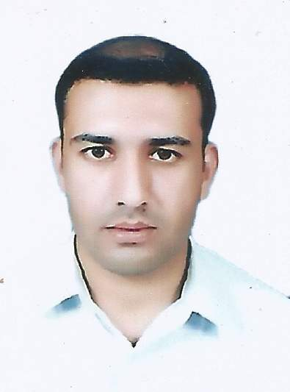
Name : Dr. Safdar (Pharm-D)
Email : Safdar.333530@2freemail.com
Date of Birth : March 10, 1985
Nationality : Pakistan Religion : Islam
Marital Status : Single
Visa status : Visit visa(9/12/2016 To 3/3/2017)
Passport Expiry: 25/01/2021
OBJECTIVE
MOH UAE : Passed

To pursue my career in a leading organization where I can improve my skills and take part actively in its progress, so that I prove myself a competent professional and will be able to serve the organization.

Degree/  Certificate | Year of Passing | Major Subjects | Marks Obtained | CGPA / %age | Div/ Grade | Institution
Pharm-D  (Doctor of Pharmacy) | 2010 | Pharmaceutical sciences | 3039/4550 | 66.79% | 1st | Gomal University D.I.Khan
H.S.S.C | 2005 | Pre-Medical | 775/1100 | 70.45% | 1st (A) | BISE Mardan
S.S.C | 2001 | Science | 667/850 | 78.47% | 1st (A) | BISE Peshawar

LICENSURE
Registered Pharmacist (Pakistan) License -PC of Category-A under the Pharmacy Council of KPK, Pakistan.
PROFESSIONAL / EXPERIENCE

- 3.5 years experience as a Retail Pharmacist in Iqbal Sons Pharmacy Swabi (From April 18th, 2011 to December 20th, 2014)
- Worked in alfalah pharmacy as a retail pharmacist from 1st January 2015 to 06 December 2016
ACHIEVEMENTS

- 45 Days Clinical Internship in District Headquarter Hospital Swabi from April 2nd, 2009 to May 18th, 2009.
- 45 Days Clinical Internship in Bacha Khan Medical Complex, Swabi from April 2nd, 2010 to May 18th, 2010.
- 30 Days Industrial Internship in Stanley Pharmaceuticals Pvt. Ltd. Peshawar.
SELF ASSESSMENT
- Languages
English, Urdu
- Computer Skills
03 months course of Office Automation from Skilled Development Council Peshawar.
- Hobbies
Books reading
Research activities
Badminton

:
DECLARATION

I would like to hereby declare with my full consciousness that all the details furnished above in this curriculum vitae are completely true to my knowledge.

