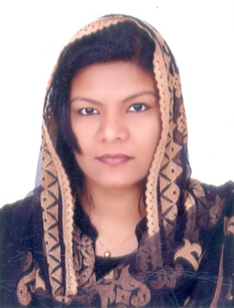

NEEMA

Abu Dhabi, UAE
Email: neema.333558@2freemail.com

CERTIFIED PROFESSIONAL CODER (CPC)

OBJECTIVE:

I am seeking employment with a progressive, reputable company that will provide challenges and opportunities for growth and advancement, utilizing my coding and billing experience and, in addition I want to work as an advancing medical coding professional in a challenging and intriguing working atmosphere with the utilization of adept coding expertise and proficiencies.

MAJOR STRENGTHS

• Highly skilled in abstracting information and assigning codes to describe each documented analysis
• Thorough understanding of anatomy, biology, pharmacology and disease management
• Strong familiarity with coding related to medicine, surgery, radiology and pathology
• Working knowledge of official coding conventions and rules established by AMA
• Demonstrated ability to liaise insurance companies regarding questions about claims
• Well versed in using computers including MS Word, Excel, Internet and Email.

SPECIAL KNOWLEDGE
● CPT | ● Code Assignment ICD-10-CM | ● Coding Guidelines
● Medical Terminology | ● Payment Methodologies | ● HIPPA Compliance
● Anatomy | ● Surgery and Modifiers | ● HCPCS Level II

EDUCATIONAL QUALIFICATIONS

• Bachelor of Science (BSC-Botany) awarded from Calicut University, India
• Higher Secondary Education (VHSE) from Board of Vocational Higher Secondary Education,Kerala. India
• Matriculation from Central Board of Public Examination,Kerala

PROFESSIONAL QUALIFICATIONS

• Certified Professional Coder (CPC-A) Certification from the American Academy of Professional Coders (AAPC).
•Passed ICD-10 Proficiency Test.

OTHER CAPABILITIES

• Meticulous with paperwork and proofreading
• Excellent communication skills
• Able to comprehend common coding procedures
• Typing Speed: 60 WPM
• Exceptional telephone etiquette.

LANGUAGES

• English- Expert (Read, Write & Speak)
• Hindi - Intermediate
• Malayalam- Mother Tongue.

PERSONAL DETAILS

Date of Birth : 01.09.1989
Nationality : Indian
Religion : Islam
Marital Status : Married
Sex : Female
Visa Status : Visiting

REFERENCE

Available on request.
DECLARATION

I hereby declare that all the details mentioned above are true to the best of my knowledge and belief.

Name:NEEMA
Place:INDIA

