Email ID : SANGEETHA.333575@2freemail.com

Qualifications PROFILE PROFESSIONAL MEDICAL coder
Dedicated and patient-focused Bachelor of Science Nurse with proven strengths in acute patient care, staff development and family advocacy with AAPC- ICD-10 Certification.
- Exceptional capacity to multi-task: manage numerous, often competing priorities with ease and foster the provision of superior patient care.
- Administrative and referral experience including admissions, assessment, treatment, referral and education for a wide range of patients.
- Widely recognised as an excellent care provider and patient advocate.
- Demonstrated ability to forge, lead and motivate outstanding healthcare teams that provide top-quality patient care.
- Outstanding interpersonal and communication skills; superior accuracy in patient history, charting and other documentation.

Educational Background

QUALIFICATION | INSTITUTION | UNIVERSITY/BOARD | YEAR OF PASING
S.S.L.C | St. Thomas High School,  Neerattupuram | Kerala State Board | 2000
Plus Two | M.G.M. Higher Secondary School, Thiruvalla | Kerala State Board | 2000-2002
BSC Nursing | Dr. M. V. Shetty Institute of Health Sciences  Mangalore | Rajiv Gandhi University | 2009
Medical Coding | ALDOS | AMCB | 2015
Accreditation | AAPC | ICD-10-CM | 2016 Dec

PERSONAL INFORMATION

Name : Mrs.SANGEETHA
Date of Birth : 04 January 1985
Age : 30 Years old
Sex : Female
Religion : Hindu
Nationality : Indian
Marital Status : married

Awards & Achievements : Received various awards in Cultural Competitions
Hobbies : Reading, Listening to music, cracking jokes, Watching T.V.
Extra Curricular Activities : Actively Participated in SNA & Cultural Competitions
Language Known : Fluency in English & Malayalam, Working knowledge in Kannada

Declaration:

I hereby that the above furnished details given by me are true to the best of my knowledge and belief. Hope that utilizing my professional skills we can certainly carve out a way, so as to meet the mutual requirements with an opportunity for personal growth and development.
Thanking you for your time and consideration.
Sincerely,

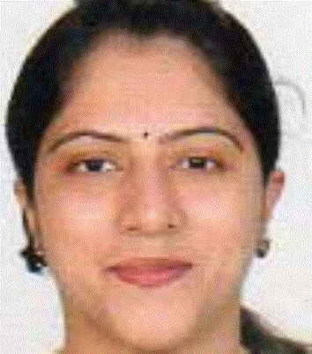
Sangeetha, CPC-A
Email/Mail Subscriptions: AAPC News, Industry News, Product Updates, Event Updates, Healthcare Business Monthly, Special Offers, Job Alerts, Local Chapter Events, ICD-10, Renewal Notices, Healthcare Business, Member Benefits
Local Chapter: Abu Dhabi United Arab Emirates
Field of Expertise:
- Employer Type: Hospital (Inpatient)
- Job Responsibility: Biller
- Education: Bachelor's

Your Exam Score: 75%

I passed my exam - now what?
Congratulations – You are now a certified member of AAPC! You join an elite group of coders who have distinguished themselves by passing the rigorous certification exam. To maintain your certification you will need to earn continuing education credits. The number of CEUs required for your first submission have been pro-rated to match your membership date. You’ll have 4.5 CEUs due by 3/31/2017.
Once you have the met the requirements for Apprentice removal, please forward your documentation to the AAPC for processing. You may send your supporting documentation using any of the following methods:

