CURRICULUM VAITE
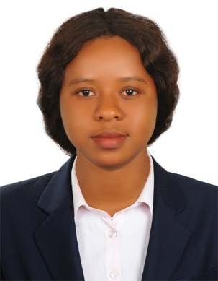

BANGURA
BANGURA.333579@2freemail.com

APPLYING FOR THE POSITION OF A WAITRESS

PERSONAL SUMMARY
A hospitable, presentable and hardworking team player who possesses a high standard of personal appearance and hygiene. Always focused on making sure that every guest is served to the highest possible standards by having an outgoing, polite
and professional attitude towards all patrons. Constantly working hard to ensure that
Guest expectations are met and that their time being served is a memorable
experience. I naturally enjoys talking to people and is much experienced in
overseeing the smooth running of a busy dining area, and in creating a unique
relaxed style and atmosphere. She is now ready for new challenges, and is now
seeking a suitable position with a reputable and exciting company.

WORK EXPERIENCE
INSTITUTION/ORGANISATION POSITION
HOTEL 5/10 | Waitress working as part of a team that includes manages, hosts and bartenders. Responsible for welcoming guests to the restaurant and promoting the food and beverage menu whilst serving/delivering food and drinks to guests.
Nectarina Sierra Leone NGO | Head of Sensitization team, Supervised School construction team, Supply food stock and school materials to school pupils.
Oxfam(NGO) | Coordinate Seminal
Kissy Kama Association | Organizing committee and chairperson regional officer
BRAC Sierra Leone | Grant and Loan facilitator

Duties:
• Delivering outstanding food and beverage service to customers.
• Taking orders from guests and offering advice on the menu.
• Giving guests an accurate bill then taking payment from them in cash or credit cards.
•Ensuring the Cashier Tally Sheets are accurate and any discrepancies are noted and signed by a supervisor.
• Adhering to all Licensing Laws and Weights and Measure Acts.
• Keeping the Place of Work and surrounding area clean and organized at all times.
• Escorting customers to their tables.
• Removing dishes and glasses from tables, and taking them to kitchen for cleaning.
• Preparing accurate checks that itemize and total meal costs and sales taxes.

KEY SKILLS AND COMPETENCIES
Familiar with all cash handling & Credit card payment procedures.
The motivation to learn new knowledge and skills.
Good Housekeeping duties.
Have a full knowledge of all food & beverage policies and procedures.

ACADEMIC QUALIFICATIONS
Diploma in Mass Communication
Fourah Bay College 2010 - 2012

Hubbies;
Reading novels, Surfing the Internet, Listing to music and Watching News.

PERSONAL DETAILS: Nationality Sierra Leonean
Date of Birth 26/10/1990
Marital Status Marriage
Visa Status Tourist Visa
Language English

