Saquib
Email: saquib.333582@2freemail.com
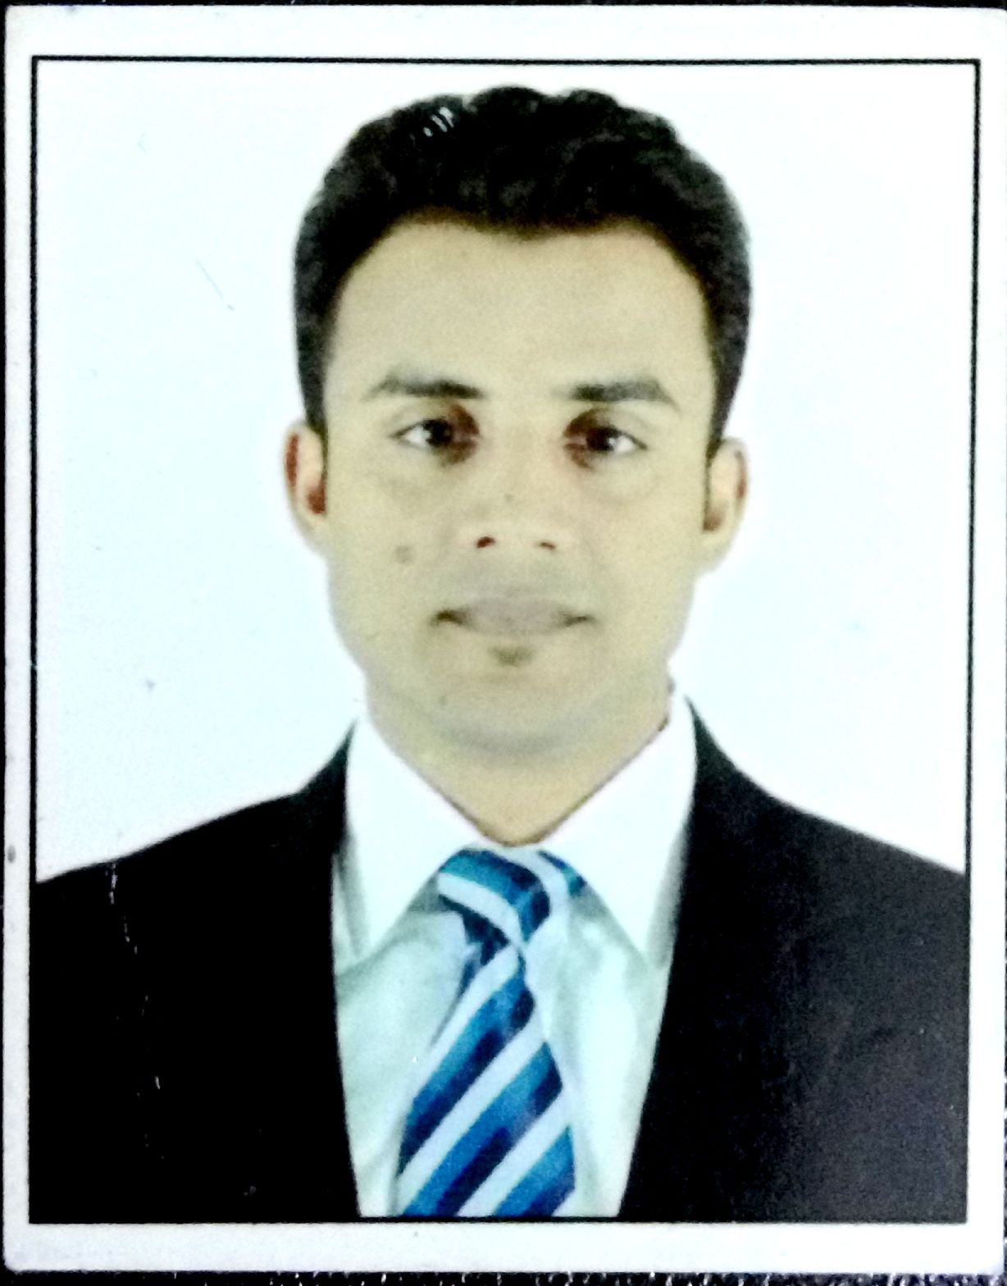
CURRICULAM VIATE

Visa Status: - Visit Visa

Career Objective:
Aspire to be a successful management professional by understanding work culture and enhance professional and personal growth.

Educational Qualifications:
- MBA (MASTER OF BUSINESS ADMINISTRATION): Mahatma Gandhi University, Meghalaya (2013-15)
- BBA (Bachelor of Business Administration):Madras university, Chennai(2009-12)
- Higher Secondary: NIOS Board(2009)
- Secondary: CBSE Board(2006)

Professional Experience:

( 5thJanuary 2016- 15thJuly 2016)
Last position held at the time of living: (“BSO” Branch sales officer)

Roles & Responsibilities:
- Dealing with all multi Bank products like “CASA, Demat, credit card, All types of loans”
- Ensure deliverance of useful and productive services to the customers.
Key Learning’s :
- Created new contacts and leads.
- Created trustful relation with customers with positive attitude.
- Identify potential clients through cold calling and walk-in
Religare Health Insurance(15thJanuary 2015 – 30th Nov 2015)
Last Position held at time of leaving : (Sales Manager)

Roles & Responsibilities:
- Dealing with Health products through bank channel.
- Ensure deliverance of Quality, Service, Cleanliness &Value to customer
Key Learning’s :
- Created good relation with customers with positive attitude.
- Cold calling to arrange meeting with potential customers to prospects for new business.

Summer Internship Project:
WIZARD INFO SOLUTION PVT LTD (5th May, 2014 – 25th July, 2014)
Project Title: - Consumer buying behavior towards different newly develop products (software’s) like ERP, WSI & others software’s.
Project Synopsis: -Selling of the software in the market according to their requirement and Order given by them which they need for their organizations.

Other Projects/ Training:
- Worked for Vodafone BPO services for 4 months in 2012
- Industrial visits in PARLE AGRO LTD Rajasthan Plant, YAKULT PVT LTD Sonipath HARYANA, BISLERI INTERNATIONAL PVT New Delhi.

Co-Curricular /Extra-Curricular Activities:
- Represented school as SPORTS CAPTAIN and SECRATARY (2005-06)
- Participated and Won inter school cricket league competition (2004-05)
- Organised collage cultural meet (SPANDHAN) (2013-14)

Core Competencies:
- Adaptable
- Flexible
- Positive attitude
- Responsable and hard working
- Loyal towards works

Personal Information:
Date of Birth : 03-12-1990
Nationality : Indian
Religion : Islam
Gender : Male
Marital Status : Single
Passport Details : / Valid Up to 23/09/2025
Languages known : English, Urdu, Hindi

I hereby decleare that all the above mentioned facts are true and correct to the best of my knowledge and belief.

DATE :
PLACE :Dubaï SIGNATURE

