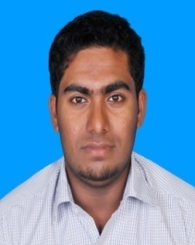

YASHIK
YASHIK.333628@2freemail.com

Summary:
Aim to be an associated with a progressive organization that gives me scope to update my knowledge and skill in accordance with the latest trends in technologies and be part of a team that dynamically works towards growth of organization and gain satisfaction thereof.

Professional Experience

Company : PMR Enterprises, Malappuram, India
Designation :Office Admin
Experience : 2.2 year

Company : Logic Park, Malappuram, India
Designation : Network & CCTVTechnition
Experience : 2 year

Educational Qualifications

- Degree in Bsc Electronics and Communication from Calicut university ( 2012)

- Higher Secondary Education from Kerala board (2008)

- Secondary Education State Board (2006)

Professional Qualification:

Cisco Certified Network Associate CCN

Other Technical Skills

Operating Systems :WindosXp,Windows 8,Linux
Photoshop
MS office

Personal Profile:

Date of Birth : 23February 1991
Marital Status : Single
Languages known : English, Hindi, Tamil
Nationality : Indian

Declaration:
I hereby declare that the information furnished above is true to the best of my knowledge and belief.
.

Place: Dubai
Date:

