WAFA
WAFA.333635@2freemail.com
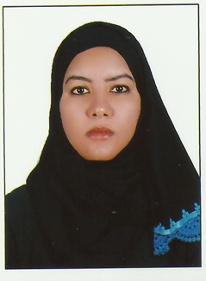

Objective : | A female pharmacist with moh evaluation on Husband ’Residence Visa & presenting this Resume for gaining a job as Pharmacist to find a permanent opportunity in a reputed pharmacy , through which I will be able to leverage my interpersonal strength while actively build my technical knowledge ,develop and maintain the highest standard of outstanding performance .
Education:  Experience  5 years as below | - Bachelor’s degree in pharmacy Unversity of science and technology (Sudan 2007  - ALnubi pharmacy Umm durman – Sudan Working as 1stPharmacist from 2012-2015  Responsibility:  -Dispensing the Prescription to the patient according to the Pushing Items & explaining the best doagse form & route of adminstration as prescriped from Physician.  - Regular follow up of the shortage Items making sure that the fast moving Items are avilabl with the enough stocks .  -dispensing supplements to patients give them advise and choices to select suitable brand.  -make orders to cover shortage from different companies and drug store.  -supervise team of pharmacists,trainee,assistants.  -make sure that medicine store as suitable condition.  -Regular follow up of validity of medicine.  -dispensing of cosmetics and advise customers and help them to select good brand.  -help customers to select paramedical.  - Alwaha Pharmacy: Umm durman _ Sudan  Working as 2nd Pharmacist from 2010 _ 2012  Skills & Qualifications :  1-moh evaluation 8--2016  2-Licensed as professional pharmacist in Sudan since Sep.2007  3-Exellent interpersonal skills. 4-Excellent knowledge and in information’s in pharmacy .  4-Ability to work well as part of a team.  5-Fluency in written and spoken English.  6- Responsible attitude to work and hard worker.  7-high commitment and time management.  Language Skills :  - Arabic( Mother Tongue )  - English(Excellent level written, spoken & reading )  Personal Data :  - Marital status : Married  - Nationality : Sudanese  - Place of birth : Sudan  - Visa Status : Valid husband’s residence visa  - Valid Sudanese driving liecence  - References are avilable on request.

